

Version 2.0
Edited by June Lee

Last updated 08 Sept 05

TABLE OF CONTENT
TABLE OF CONTENT 2
1.1 Technical Specifications 4
1.2 Features 4
1.2.1 Stackable 5
1.2.2 Large Programming Table 5
1.2.3 Four-stage Pre-programmed Dialing 5
1.2.4 Five Routes 6
1.2.5 Handshaking Capability 6
1.2.6 Prefix Number Removal 6
1.2.7 End Code Attachment 7
1.2.8 Multiple User Account 7
1.2.9 Adjustable Dialing Speed 7
1.2.10 PABX / Centrex System Support 7
1.2.11 Bypass Switch 8
1.2.12 Temporary Bypass Code 8
1.2.13 Local and Remote Programming 8
1.2.14 Phone and PC Programming 9
1.2.15 Local and Remote Programming Password 9
1.2.16 Routing indication (beep.. beep) 10
1.2.17 Auto-Rerouting 10
1.2.18 Call Home For LS4000 10
1.2.19 Line Reversal For LS4000 10
1.2.20 Call In Caller ID For LS4000 11
2 Auto Dialer Connection Guide 12
2.1 Normal Single Telephone 12
2.2 Normal Telephone Parallel Extensions 12
2.3 PBX on C.O. LINE Side 13
2.4 PBX on Extension (Intercom) Side 13
2.5 Multi-Line Application 13
2.6 Special Environment 14
3 Auto Dialer Programming 15
3.1 Overview 15
3.2 Getting Started 16
3.3 Programming Steps 16
3.3.1 Local Programming Using Phone 16
3.3.2 Remote programming Using Phone 17
4 Programming Parameter 18
Appendix I - PROGRAMMING PARAMETER TABLE 26
Appendix II – Setting Examples 30
Scenario 1 : Routing to 1 gateway only. It works for any type of gateway 30
Scenario 2 : Try gateway 1, if fail try gateway 2, if fail fall back to Telekom. Works for DTMF gateway only 30
Scenario 3 : Try gateway 1, if fail try gateway 2, if fail generate engaged tone. Works for DTMF gateway only 30
Scenario 4 : Try gateway 1, if fail try gateway 2, if fail fall back to Telekom. Specially for IVR gateway only 30
Scenario 5 : Try gateway 1, if fail try gateway 2, if fail generate engaged tone. Specially for IVR gateway only 31

Technical Specifications

Item | LS4000
Dimension | 105*70*30mm
Weight | 100g
Power Consumption | 120mW
Minimum Operating Voltage | Line: 28V, CPU: 2.5V
Chip Set | Holtek HT95A40
Built-in Memory | 8K bit

Features
Our dialers’ features include:
- Stackable
- Large programming table
- 4-Stage pre-programmed dialing
- Five routes
- Handshaking ability
- Prefix removal
- End code attachment
- Multiple user account
- Adjustable dialing speed
- PABX/ Centrex system support
- Bypass switch
- Temporary bypass code
- Local and Remote programming
- Phone and PC programming
- Local and remote programming password
- Routing indication (beep.. beep)
- Auto Re-routing
- Call home
- Line Reversal

Stackable
The simple, stackable design of LS4000 makes multi-line installation much easier, practical and economical.
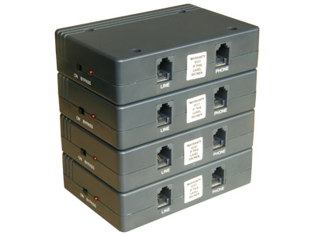
Figure 1 - Stackable design for easier and neat installation

Large Programming Table
Using big capacity flash memory, our dialers contain large programming table as many as 95 parameters. At the activation number entries, it can store up to 128 activation numbers with maximum 6 digits.

Four-stage Pre-programmed Dialing
When the dialer detects the activation number, it can dial up to 4 stages of numbers according to the setting. Typically, the 4 stages are allocated for access /gateway number, language selection, ID, password, card number, etc.

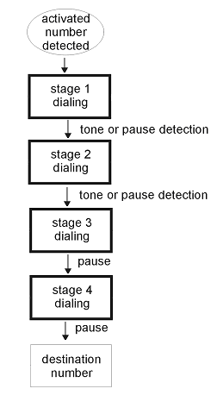
Figure 2 - Four Stages Dialing Sequence Supported by Auto Dialer

Five Routes
Each dialer can be programmed for 5 different alternative carriers. Each route can program its own activation number and 4-stage numbers. The routing is decided by the programmed activation table.

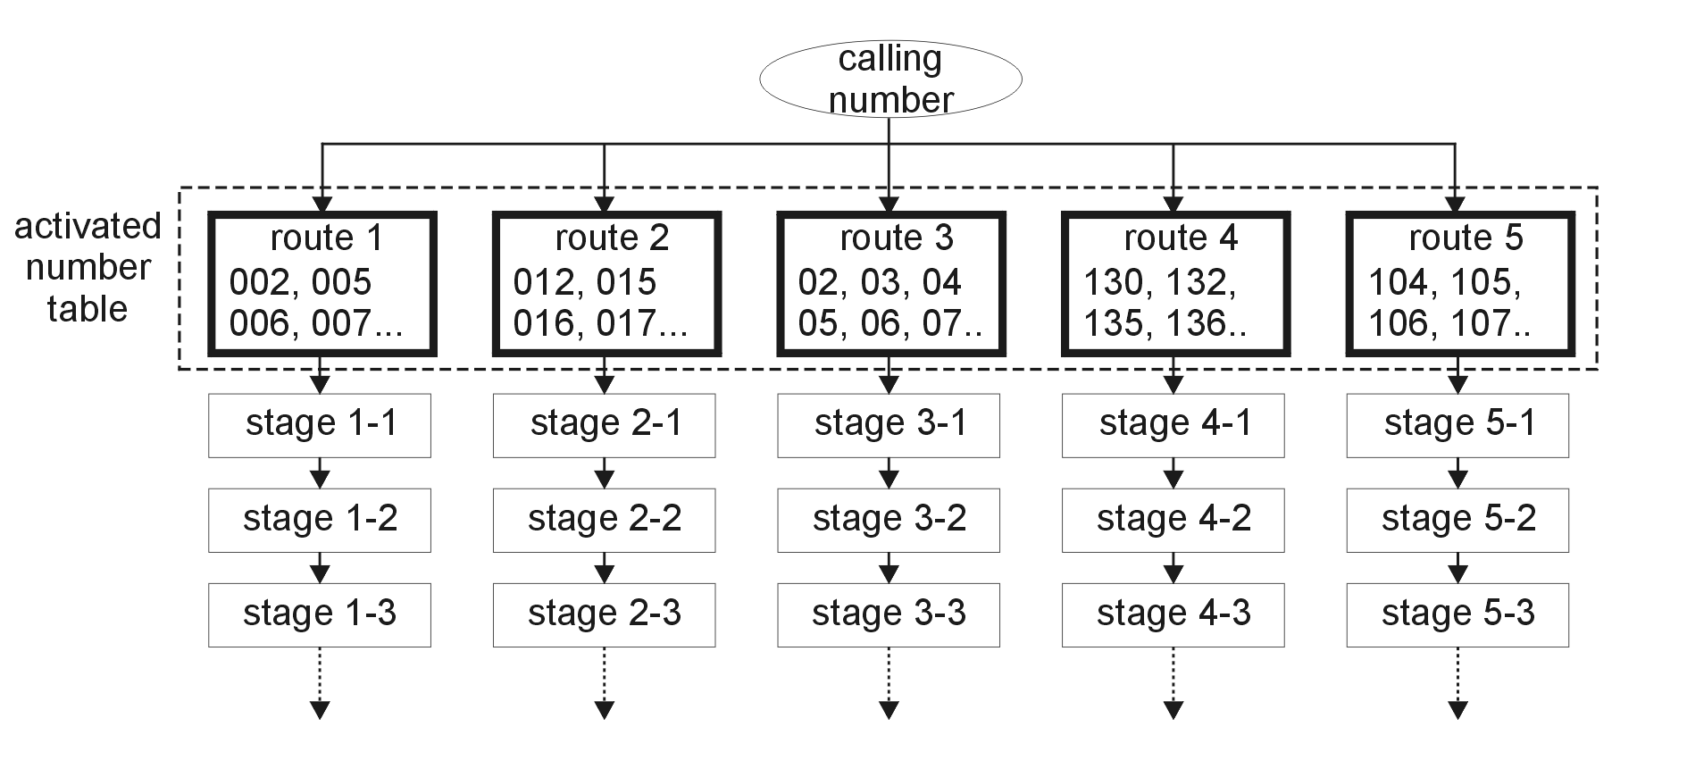
Figure 3 - Four Stages of Dialing Available for All 5 Paths

Handshaking Capability
Built-in multi tone detector can detect DTMF and second dial tone signal from carriers’ gateways. This allows our dialers to dial out each stage on proper timing, without having to wait for wait for timeout.

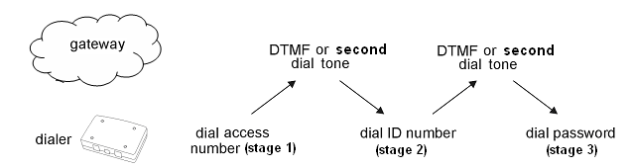

Figure 4 – Handshaking

Prefix Number Removal
When the dialer dials out the destination number, it can dial full destination number, or remove the prefix number according to the setting. Maximum 6 digits can be removed.
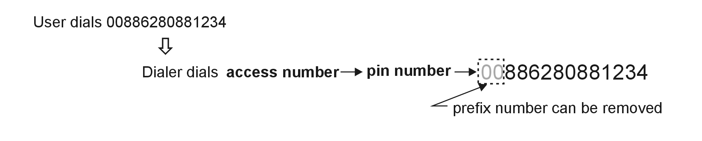

End Code Attachment
Our dialers can be set to automatically append end code to the end of destination number, for example, #, *, # #.
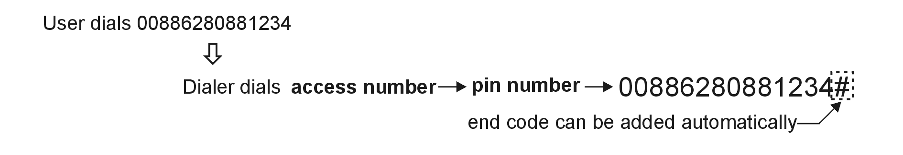

Multiple User Account
This feature allows multiple users access one common account, using separate pin codes. Users need only to dial the given pin code prior to dialing and the dialer automatically generate a separate listing of all calls made by that user/ department. The dialing pattern is
# PIN # Destination Number
For example,
# 12345 # 0012345678
Where PIN as 12345, 0012345678 is destination number.

Adjustable Dialing Speed
This feature allows adjustment of DTMF dialling speed. If the telephone line and gateway is well integrated, a shorter dialling interval can speed up the connection time. If the telephone line and gateway quality is normal, slowing down the dialling speed can improve stability and hence increase successful connection rate.

PABX / Centrex System Support
Our dialers can connect on line or phone terminals of the PBX. While connecting to the phone terminal, user can program the C.O. line access code (0, 9 or others) and pause time to access C.O. line. Users do not have to change their dialling habit.

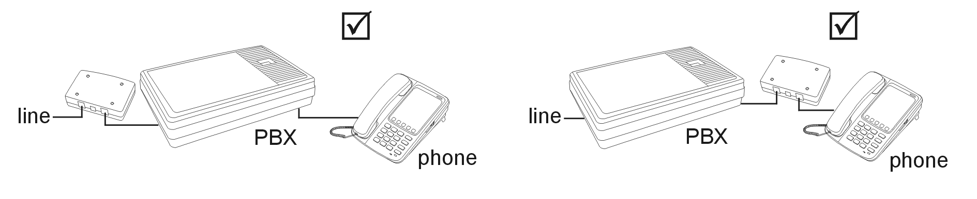
Figure 5 - Support Installation of Dialer Before or After PABX

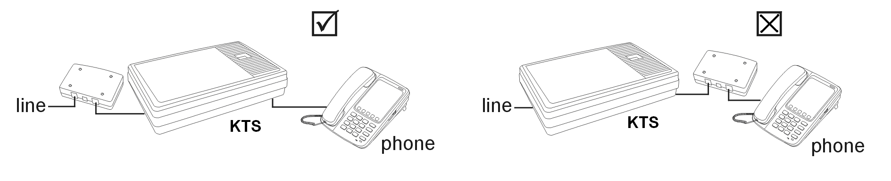
Figure 6 - Support Installation of Dialer Before KTS

Bypass Switch
A mechanical switch is designed on all our dialers. This is designed to ensure users can still make phone call through regular phone line when the gateways are down, or when the dialers are faulty.

Temporary Bypass Code
A programmable function code can be used to disable the dialer for one call. For example, when a user dials the bypass code (by default is #2#), the dialer will bypass to C.O. line. User will hear a ‘beep’ tone followed by the C.O. line dial tone. Dialer will resume its work for the next call. This bypass code can be programmed based on user’s choice.

Local and Remote Programming
Our dialers can be programmed locally and remotely.

To program locally, connects the dialer to a phone and a PSTN line or line simulator. See Figure 7.
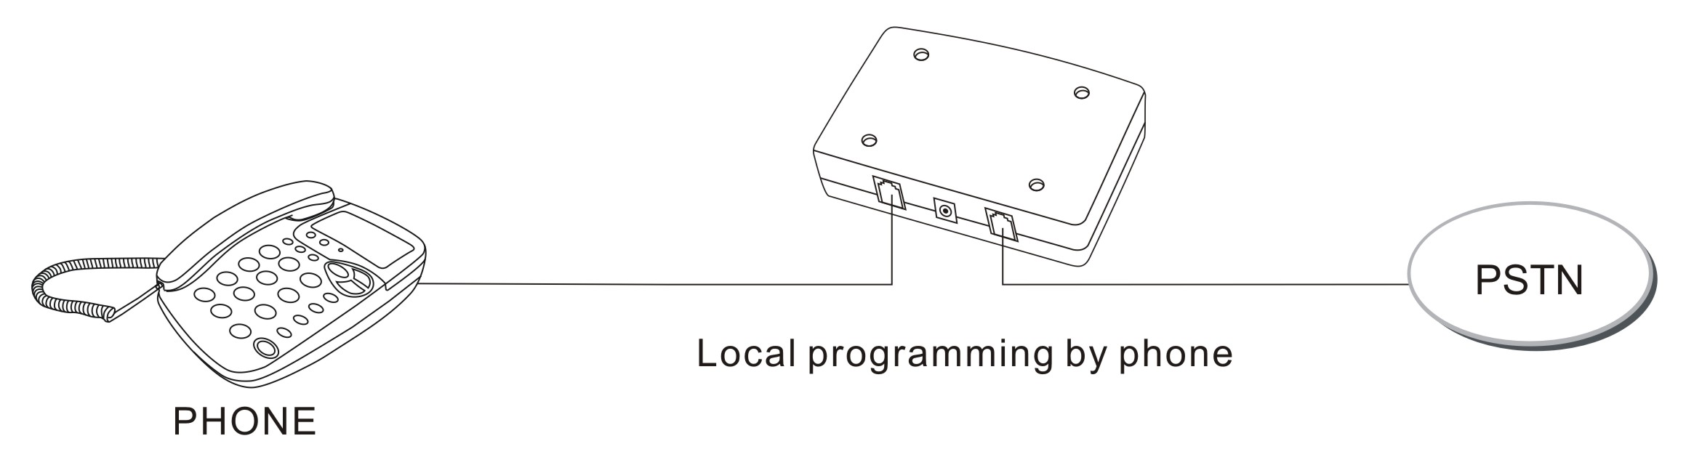
Figure 7 - Local Programming (Using Phone)

To program remotely, dial from service centre to the line that connects to the dialer at the customer site. To enable programming, the phone at the customer site has to be picked up. See Figure 8.
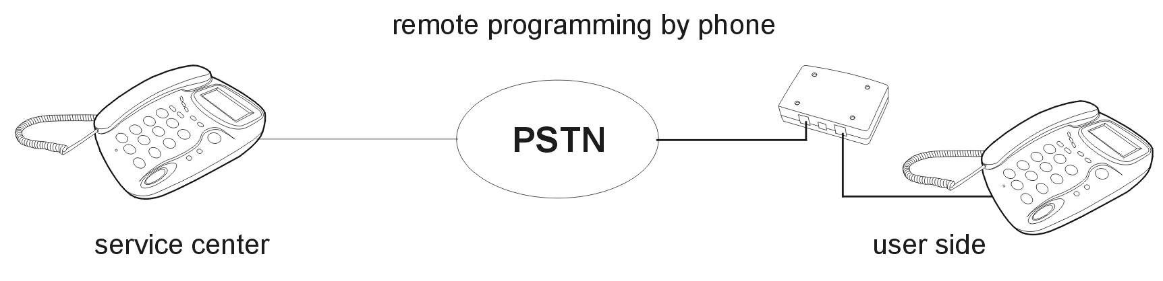
Figure 8 - Remote Programming (Using Phone)

Phone and PC Programming
Besides the normal programming way using phone, we also design the PC-based programming kit LM4000 t program all our LS4000 dialers. This will greatly save time and reduce possible mistakes, in comparison to manual setting. The programmer can also retrieve the settings of the LS4000 dialers.

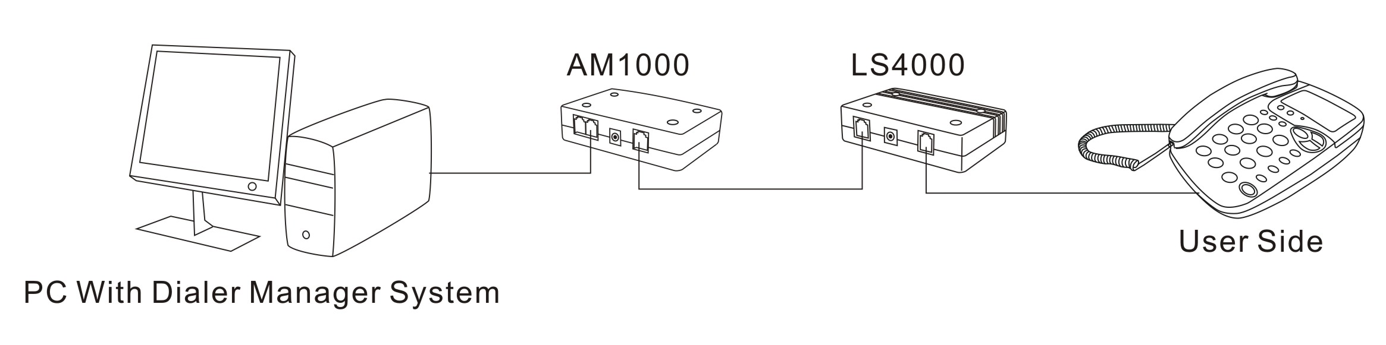
Figure 9 - Local Programming (Using PC)

Correspondingly, this programming kit LM4000 can also be used to program dialer that is installed at end user’s site.

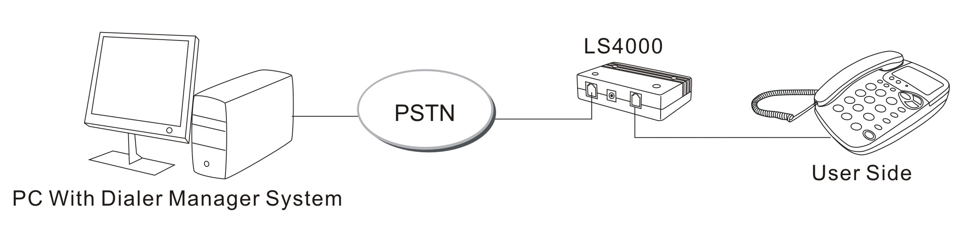
Figure 10 - Remote Programming (Using PC)

Local and Remote Programming Password
All the 4 models of dialers have 2 sets of passwords, one for local programming, and one for remote programming. This will prevent unauthorized changes to the dialer settings.

Routing indication (beep.. beep)
When the dialer starts translating the telephone number to gateway, a routing indication sound (beep.. beep..) can be heard from the phone. This is to indicate to the user that the call is being routed to gateway.

Auto-Rerouting
When the gateway is down or busy, the dialer can reroute the call to another gateway number, or to the regular telecom. The requirement for this feature is to have DTMF or dial tone received from gateway upon successful connection.
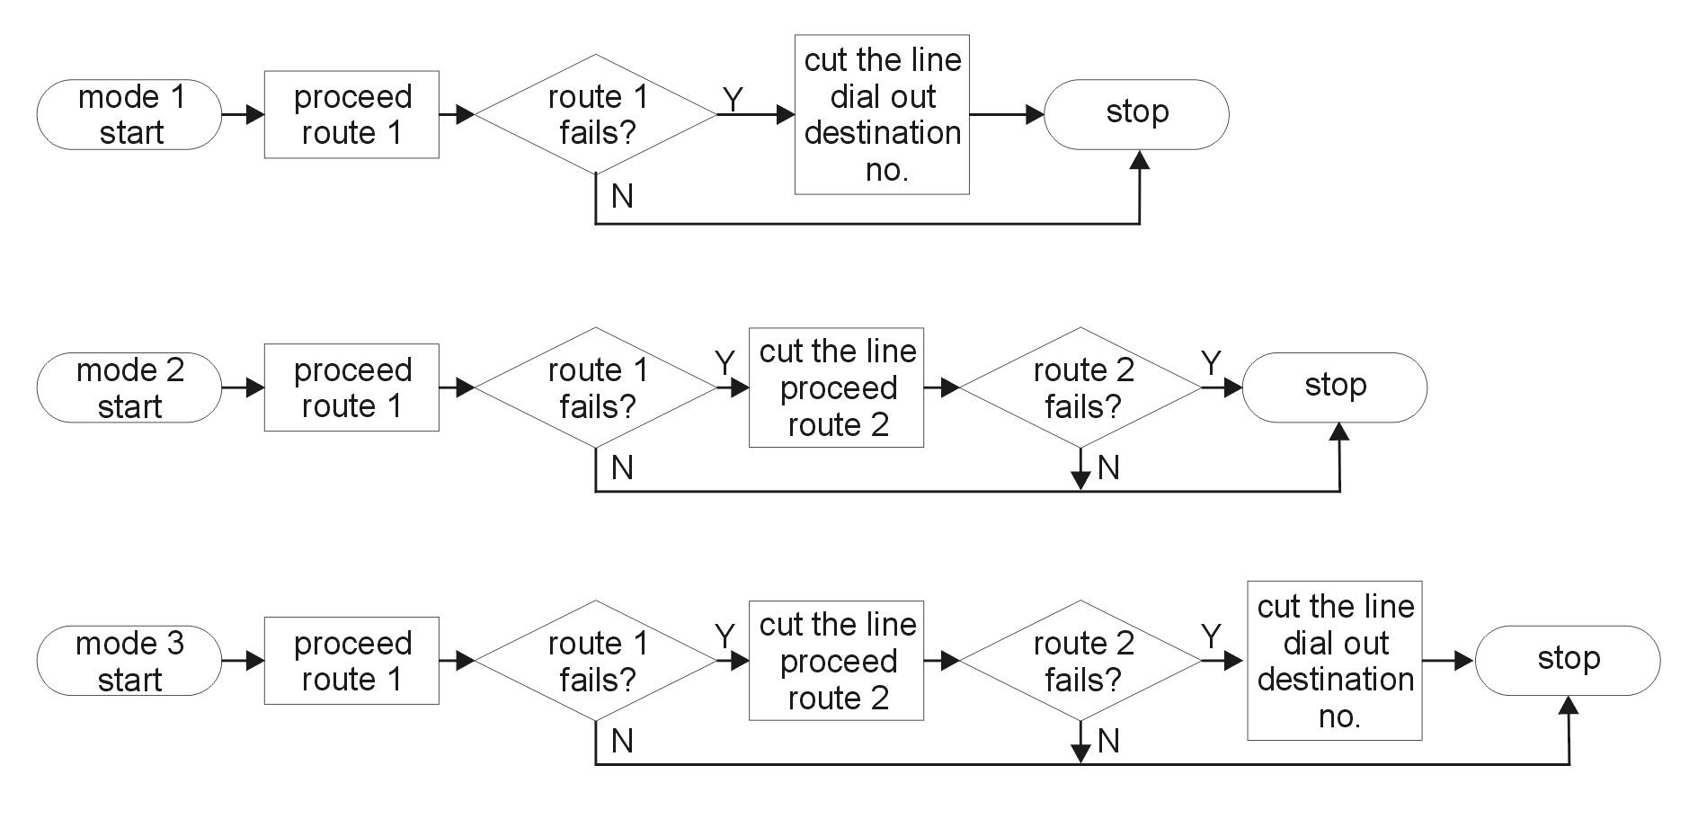
Figure 11 - Auto Rerouting Sequence

Call Home For LS4000
This feature allows the LS4000 dialers to “Call HOME” (a management server) at certain time interval. When the pre-set time interval is up, the dialer will call the pre-programmed number (the server) to ‘report itself’ that it is still ‘alive’. At the same time, the dialer will update itself with newer version of settings, if available. This feature is available for model LS4000. LS4000 dialers have been tested to be able to work under caller ID DTMF and FSK format. Malaysia’s caller ID is FSK format.

Line Reversal For LS4000
These specially designed models can hold the line reversal from the telecom, until it receives the confirmed connection signal from the gateway (e.g. C-tone). This is to avoid the incorrect billing by the line reversal billing system. The connection signal accepted by our LS4000 dialrs are A, B, C, D, *, or #.

Call In Caller ID For LS4000
This new feature is designed only for LS4000. It allow server to set management server’s number or call home number. The server can make a call to the dialers and cut off, the dialer will call home for update automatically.

Auto Dialer Connection Guide

Normal Single Telephone
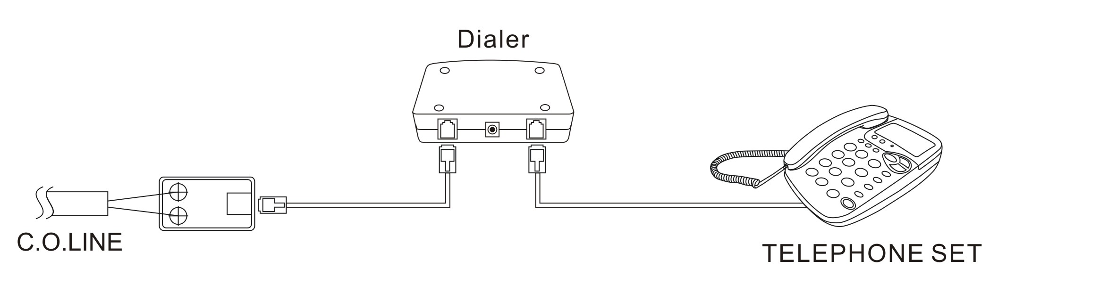
Figure 12 – Normal Single Telephone Connection

Normal Telephone Parallel Extensions

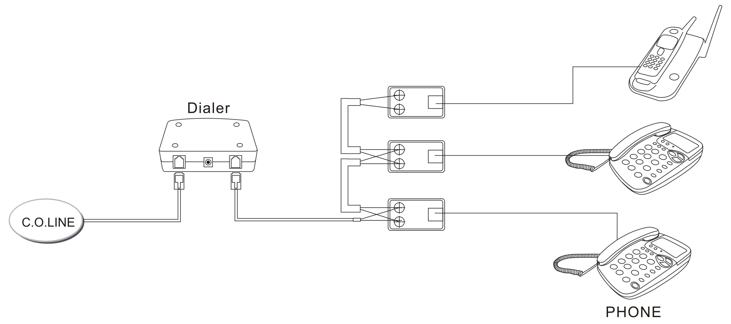
Figure 13 - Normal Telephone Parallel Extensions

  - Must connect at the origin of telephone line, so all telephone sets can activate the dialer.
  - If the dialer is not installed at the origin, just installed in front of a telephone set, then only this telephone set can activate the dialer.
  - This type of connection usually involves transferring line among the telephone sets, so the on hook settings of the dialer should be set to minimum 0.8sec. This is to avoid the dialer to misjudge transfer line as cut off line. Otherwise the user on the dialer side will not be able to hear any tone from the other party.

PBX on C.O. LINE Side
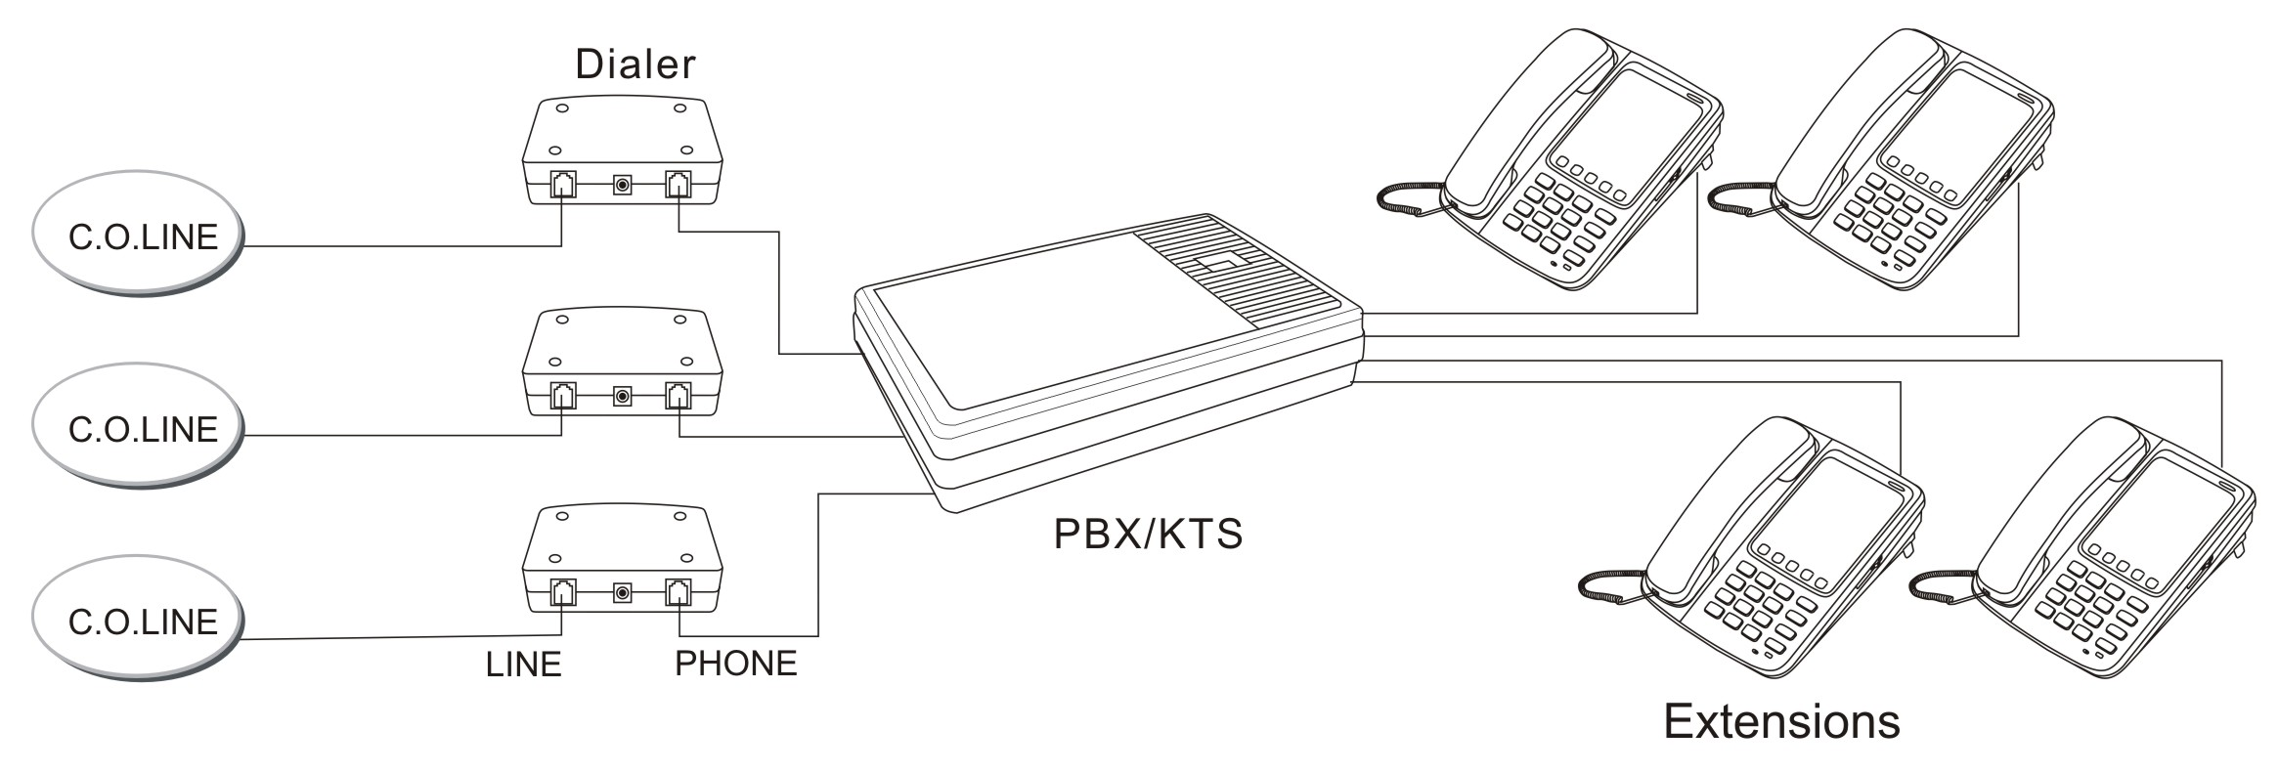
Figure 14 – PBX on C.O. Line Connection

  - Connect between C.O. Line and LINE terminal of PBX/KSU
  - All extensions can access the dialers

PBX on Extension (Intercom) Side
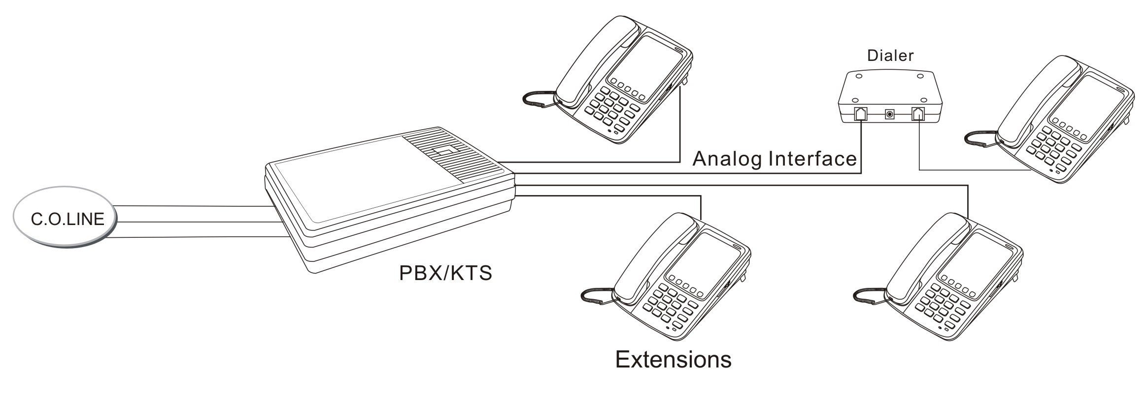
Figure 15 - PBX on Extension (Intercom) Side

- Only analogue intercom interface of PBX can apply this connection
- KTS and digital phones are not workable with this connection
- When the dialer is connected in this way, parameter [83] and [84] must be programmed.
- Only the extension which connects with dialer can do auto dialling.

Multi-Line Application
For more than one dialer, can stack up as the figure below:

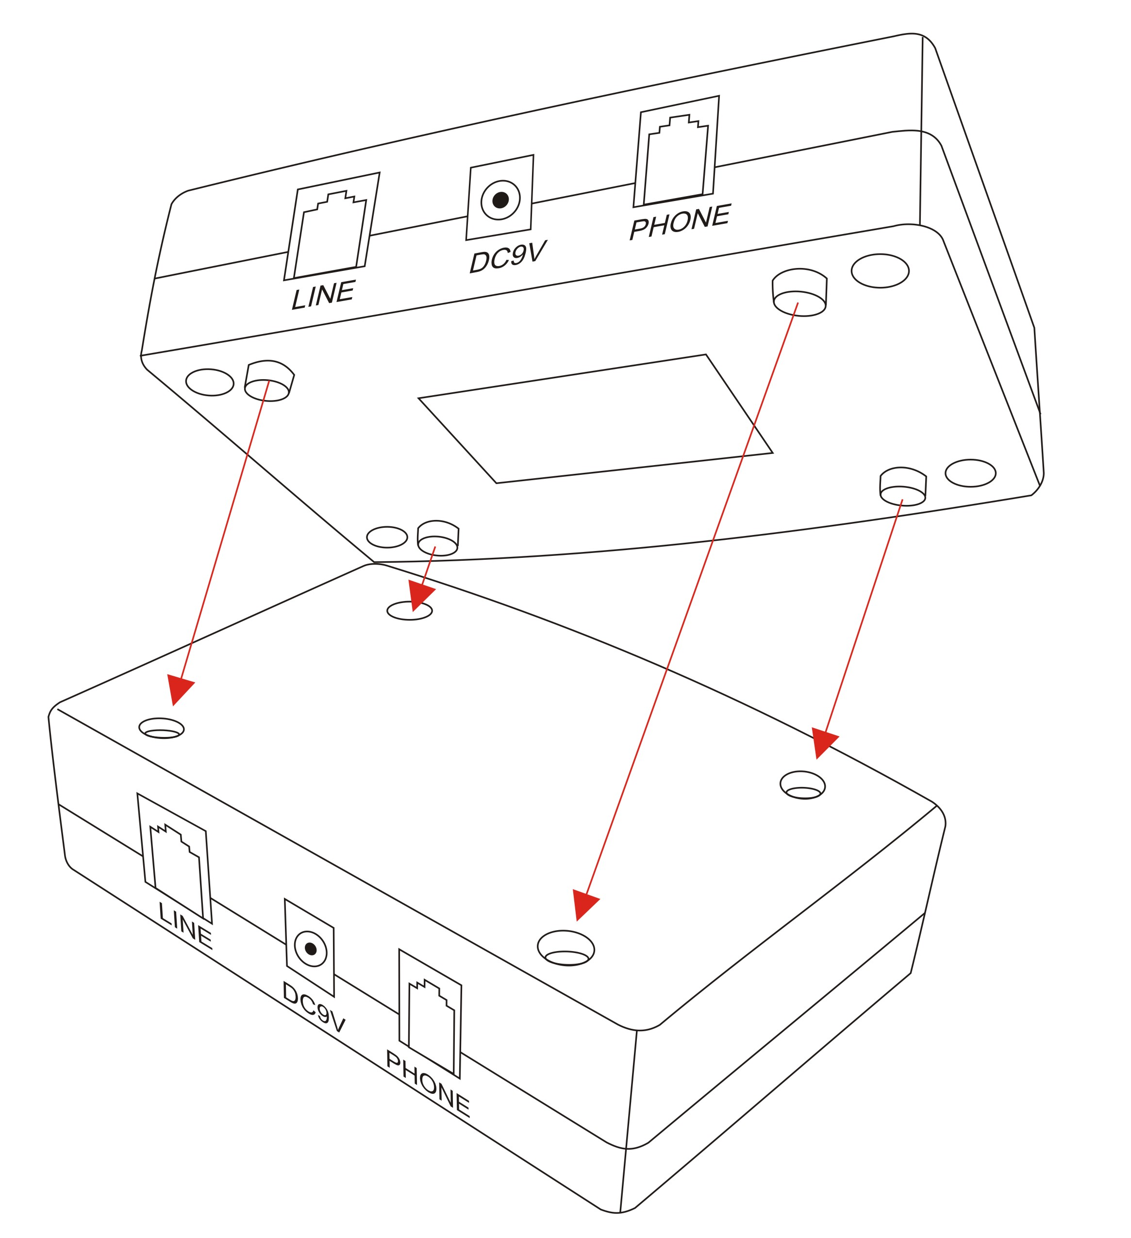
Figure 16 - Stacking up auto dialers

Special Environment
- ISDN

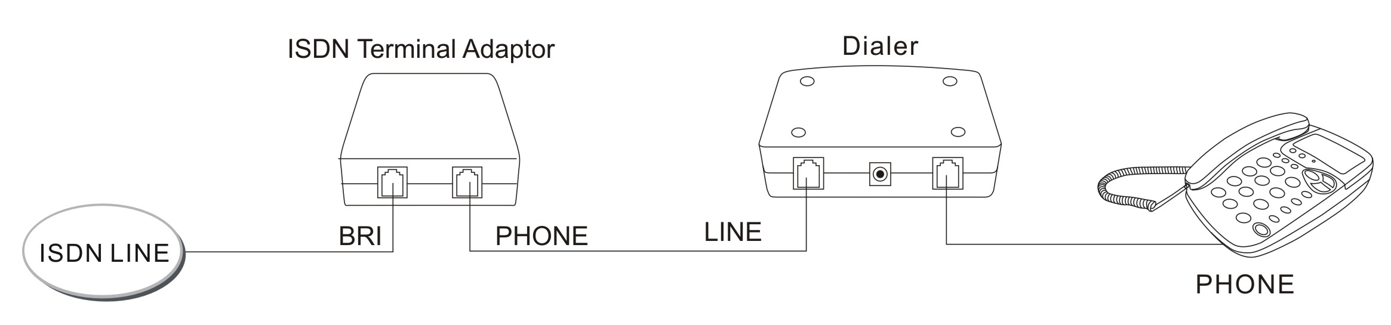
Figure 17 – Connection in ISDN Environment

  - Our dialers can only work on analogue line. For ISDN, must connect between ISDN TA’s and analogue telephone set.

- ADSL
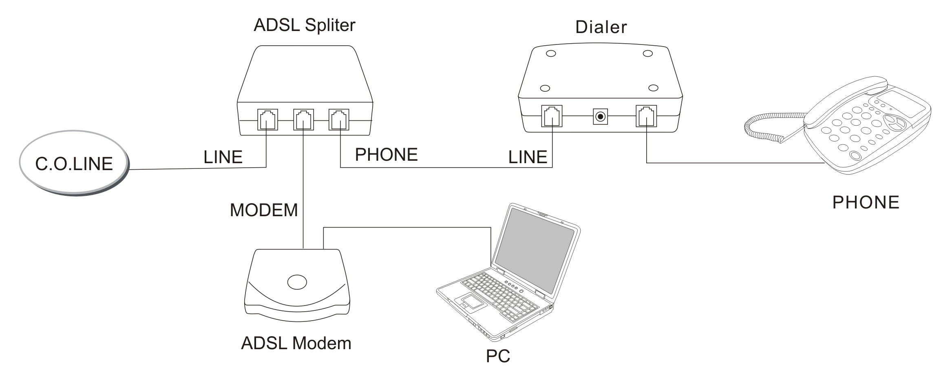
Figure 18 - Connection in ADSL Environment

  - Dialer must be installed between the ADSL splitter and telephone set

Auto Dialer Programming

Overview
All our auto dialer series can perform:
- Local programming through FSK or DTMF touch tone phone
- Remote programming on-line through FSK or DTMF touch tone phone
We also have the PC-programming options for all our auto dialers to do local and remote programming:
Dialers | Programming hardware | Programming software | Management software
LS4000 | LM4000(PCI card) + AM1000 | Dialer Manager System | Dialer Manager System
Table 1 – PC-programming options for LS4000 dialers

The dialers come with a set permanent factory default value.
If user is required to set the parameter of the auto dialer, it is suggested that user should reset the content of the dialer to the factory default values to avoid confusion.

Getting Started
To start with dialer programming, connect the dialer as shown from Figure 7 to Figure 10.

For local programming (phone or PC):
- Lift up handset (see Figure 19)
- Observe if the LED light on the dialer is on. Make sure the switch is at ‘ON’ mode.
- Start with the programming
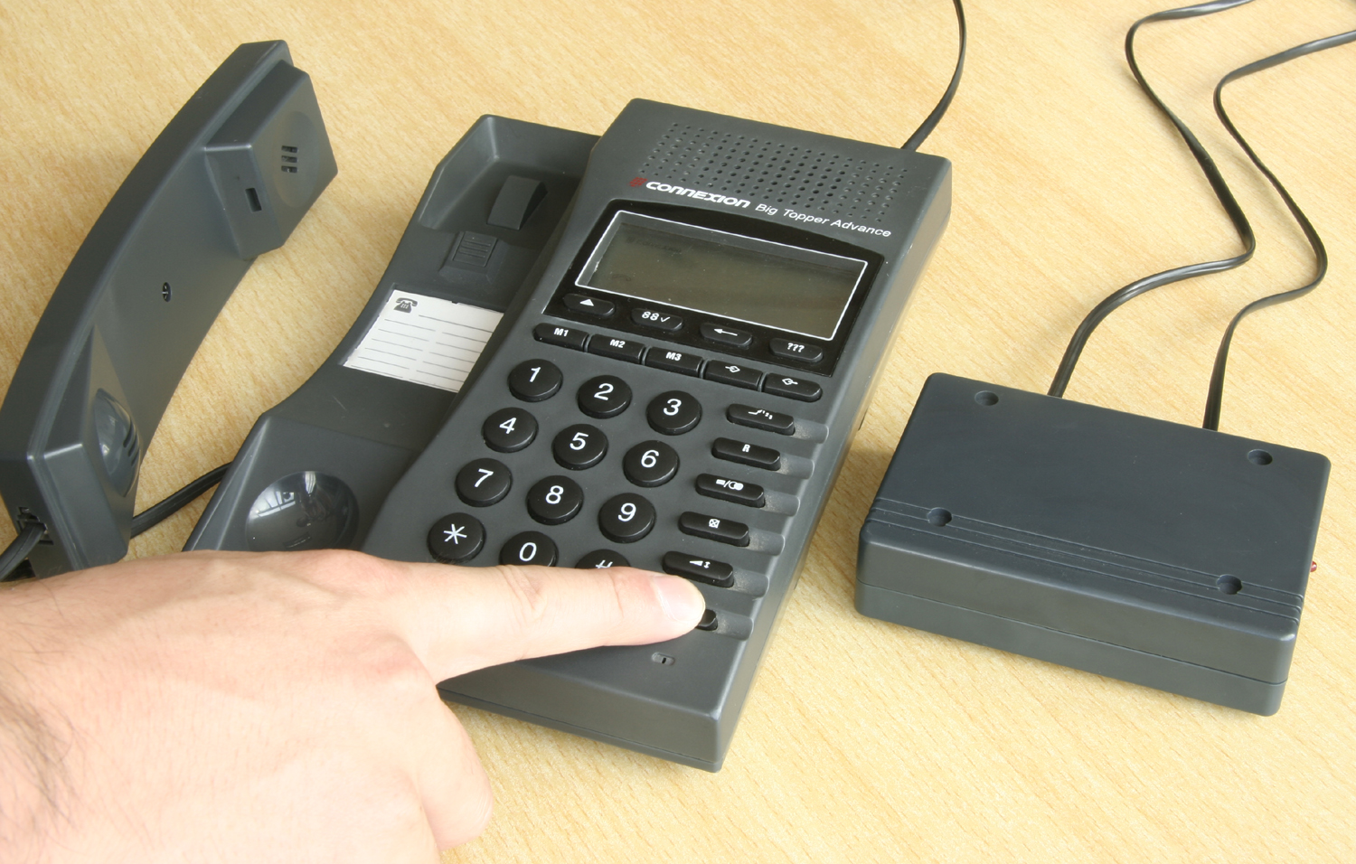
Figure 19 - Lift up handset when doing local programming

For remote programming (phone or PC):
- From the service centre, call to the line that connects to the dialer that you wish to program
- Allow the user to answer the call
- Start with the programming

Programming Steps
The programming step on our auto dialer is rather straight forward.

Local Programming Using Phone
As mentioned in Section 3.1, it is recommended to first reset the dialer to the default factory value.

- Lift up the phone handset
- Enter # 1 # [“beep” ]
- Enter Parameter number 99 to reset [“beep”]
- Enter * # to save [Long beep]
- Hang up the phone

After resetting, you can start with the programming. The steps are as illustrated below:

- Dial # 1 # [“beep”]
- Enter Parameter code [“beep”]
- Enter the control value
- Enter * # to save [Long beep sound]
- Repeat step (ii) – (iv) for next settings

The parameter codes do not have to be in sequence.

If you have set the local password in the dialer, step above will have to be:

Dial # 1 # [password] [“beep”]
Without password, you will not be able to access the parameter table in the dialer.

Remote programming Using Phone
- Lift up the phone handset
- Using PSTN line, call to the user that connects to the dialer that you wish to program. Allow user to pick up the call.
- Enter # 1 # [“beep”]
- Enter remote password [default is ‘1111’] [“beep”]
- Enter parameter code [“beep”]
- Enter control value
- Enter * # to save [Long beep]
- Repeat steps (v) - (vii) to change other parameter value
- Wait for 6 seconds to exit programming mode [“beep”x 4]
During the programming, if you pause for more than 6 seconds, you will hear 4 “beep” sounds. This means that you have already exit from programming mode. If you wish to continue programming, just repeat step above.
Do not hang up the telephone during programming mode. Wait for the 4 beep tones after pausing for 6 seconds before hang up.

Programming Parameter
THE PATHS
The dialer has 5 paths and each path is able to autodial 4 groups of number with controlled timing either through timing or response from the server. The activation code (66-70) determines which path will be used for the dialing.
INPUT FOR EVERY PATH
The input of the DTMF Tone consist of numbers 0,1,2,3,4,5,6,7,8,9,0, *,# and “A”,”B”,”C”.
UNITS
It is important to note what the unit represents prior to setting the parameter value. The units could be 10 milliseconds, 100 milliseconds, or digits.
AUTO-ROUTING
The parameter 050 – 059 is used for the application of auto-routing the dialing for the 5th Path if dialing the First Stage Number failed. The unit will auto-dial the numbers in sequential order from 050, 051,052… until the access to the server is through.
This section applied to Path 1 through Path 5
FIRST STAGE ACCESS NUMBER [01-05]
This parameter save the first group of numbers to be sent out if the dialer detects the user input numbers (Start Code: 66-70) from Path 1 to Path 5.
FIRST STAGE WAIT TIME [06-10]
This parameter controls the waiting time of the dialer before sending out Second Stage Number after sending out First Stage Number.
SECOND DIAL TONE DETECTION [11-15]
This parameter controls the dialer recognition method for the second dial tone. By setting the duration of the tone from the server to be considered as a “Go Ahead” signal, it reduces the chance of dialing out by picking up noise from the line.
The unit used is 0.1sec or 100ms. Normally this parameter is recommended to set to 15, which stands for 1.5seconds. If this value is set too short a time, the dialer may misjudge a noise as a signal to dial out Second Stage Number and if it is too long, will make the dialing process very slow, or may not even detect the dial tone.

DTMF DETECT [16-20]
This parameter controls the dialer response when received a DTMF signal from the server before sending out the Second Stage Number.
It is also used to control the feedback tone of the dialer.
Value=14
The default value of DTMF Detect is 14 for Automatic Detection. The dialer will detect any of the DTMF code sent from the server before sending out the second stage number. If there is no DTMF tone detected, the dialer will wait for the time out and send out the second stage number. It will not route to the next available gateway.
Value=15
If set DTMF Detect=15, the dialer will detect any of the DTMF code sent from the server before sending out the second stage number. If there is no DTMF tone detected after the First Stage Wait Time, the dialer will route the call to CO line.
Value=16
If set DTMF Detect=16, when either the First Stage Wait Time is over or there is no Second Tone detected, the dialer will cut off the line and seek for another path whose DTMF Detect is also 16. In other words, the value of the DTMF Detect of the alternative paths should also be set to 16.
If the dialer still unable to receive response from secondary provider after the routing, it will end its function by dialing out the number directly through the main Telco provider (IDD call).
If you wish not to route the call back to main Telco provider, set all routing paths’ values to 17. See below.
Value=17
If set DTMF Detect=17, when either the First Stage Wait Time is over or there is no Second Tone detected, the dialer will cut off the line and seek for another path whose DTMF Detect is also 17. In other words, the value of the DTMF Detect of the alternative paths should also be set to 17.
If the dialer still unable to receive response from secondary provider after the routing, it will end its function by cutting off the line. End user will hear dial tone from main Telco provider.
If you wish not to let end user hear the dial tone from main Telco provider but rather to create engaged for the end user, you will have to set the last routing path’s Second Tone Detection [11-15] to value less than 06. For example, your last available routing path is Path-3, typically your settings for parameters [11]-[20] would be:
[16] = 17, [17] = 17, [18] = 17, [13] = 03
SECOND STAGE NUMBER [21-25]
This parameter saved the second group of numbers to be sent out if the dialer wait until First Stage Wait Time, or detect Second Detection Tone, or received a DTMF Detect from the server.
SECOND STAGE WAIT TIME [26-30]
This parameter controls the waiting time of the dialer before sending out Third Stage Number.
ROUTING INDICATION SOUND [31-35]
It is used to enable or disable the routing indication sound. All paths are independent.
This can also be used for second stage DTMF tone detection from the gateway.
THIRD STAGE NUMBER [36-40]
This parameter saved the third group of numbers to be sent out if the dialer wait until Second Stage Wait Time or received Second Stage DTMF Detect from the server.
THIRD STAGE WAIT TIME [41-45]
This parameter controls the waiting time of the dialer before sending out Fourth Stage Number
FOURTH STAGE NUMBER [46-50]
This parameter saved the fourth group of numbers to be sent out if the dialer wait until third stage wait time from the server.
FOURTH STAGE WAIT TIME [51-55]
This parameter controls the waiting time of the dialer after sending out the Fourth Stage Number.
END CODE # [56-60]
This parameter controls the adding of the # key after the last dialed number is being sent out. It is also used to set the timing to add the last ending number.

Example a: 1# means “after 100ms, send the # keys”
Example b: 2## means “after 200ms, send the ## keys”
MULTI ACCOUNTS/PINS [61-65]
This parameter controls the insertion point of the customer’s individual PIN. This is only used for multiple PIN before destination number. For example, if the flow is
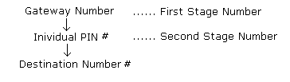
The customer should dial in the format of:
# PIN # Destination Number
Whereas the settings for Second Stage Number and Multiple PIN should be:
[21] = #
[61] = 20, where ‘2’ means PIN will be inserted at the second stage (where the # is), and ‘0’ means the PIN will be inserted at the 0th position (in front of #). This setting is independent of length of PIN.
If the PINs generated have common digits at the front, you can choose to store partial PIN into the dialers. Lets say the PINs are 8 digits long, and the format is 1234****, where the front 4 digits are the same for all the users in that company. You can set:
[21] = 1234#
[61] = 24, where ‘2’ means PIN will be inserted at the second stage (where the 1234# is), and ‘4’ means the PIN will be inserted at the 4th position (between ‘4’ and ‘#’).
ACTIVATION NUMBER [66-70]
This parameter save the activation numbers, typically the prefix of the destination numbers to be routed to alternative gateway. It can hold up to 128 values per path.
PREFIX REMOVAL [71 – 75]
This parameter removes the prefix of the dialed out numbers after the dialer have sent all access numbers. Maximum 6 digits can be removed.
Use wildcard “*” to represent any numbers for the prefix of the original dialed number.
Example:
User dial: 06-12345678 (66 = 06)
Prefix to be deleted: 03 (71 = **)
Dialer delete prefix ‘06’ and sends only 12345678 to the gateway.
EXCEPTIONAL ACTIVATION NUMBER [76]
The value in this exceptional activation number simple means that the dialed number prefix matches the activation number but to be bypassed by the dialer. The purpose of this is to allow the dialer to automatically bypass the auto-dial mode although the users dial a number that is specified inside the Start Code.
Example of application:
The end user chooses to route all numbers that start with ‘0’ except for ‘010’
Activation Number, [66] = 0
Exceptional Activation Number, [76] = 010
When customer dial 010-12345678, the dialer recognizes that 010 as invalid start code, and dial this number out though the main Telco provider.
DEL ACTIVATION CODE & EXCEPTIONAL CODE [77]
This parameter removes the entry of [66-70] and [76]. This is because for parameters [66-70], [76] each of them can store up to 128 entries. Each time a new entry is inserted at the parameter, the new entry will be appended to it, the previously entered entries are all remained inside the parameter. So this code is used to delete the particular entry inside the parameters.
For example, you have entered
(66) 0 * #
(66) 1 * #
You would like to remove activation code ‘1’ from (66). To do this:
(77) 1 * #
Another example, you entered
(66) 0 * #
(76) 0 * # (entered by mistake)
To remove ‘0’ from (76), do:
(77) 0 * #
This step will actually remove the ‘0’ from (76) and (66). So please do not forget to re-enter (66) 0 * #.
Please note that by doing (66) * # will not remove the values inside (66).
DTMF ON TIME [78]
This parameter controls duration of the DTMF signal. You can use this to adjust the dialer’s dialing speed when sending out digits.
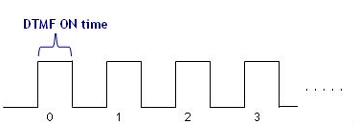
DTMF OFF TIME [79]
This parameter controls duration between the DTMF signals. You can use this to adjust the dialer’s dialing speed when sending out digits.
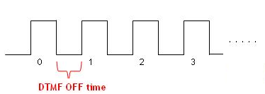
BYPASS CODE [82]
This parameter save the code required for the user to by-pass the dialer. The user has to dial the bypass code prior to dialing out if he wishes to make a direct call (not for local calls).
PBX CODE [83]
This parameter is used to take care of the PBX / Centrex access code dialed by user to get the external line, so that the dialer knows that it is the PBX/ Centrex code and not a local number. This setting is only needed if the dialer is installed between PBX and phone.
PBX CODE PAUSE TIME [84]
This parameter is used to set the timing to wait for a response from the PBX / Centrex after sending out the PBX Code for external access line. This setting is only needed if the dialer is installed between PBX and phone.
REMOTE PASSWORD [85]
This parameter is used to set the password required to program the dialer from remote area through PSTN line.
EEPROM SERIAL NUMBER [86]
This is used to store serial number inside the EEPROM of the dialer. Factory reset will not erase this value. For change/set, do
#1# 86 **** new serial number * #
ON HOOK TIME [87]
This parameter is used to set time required for the dialer to determine if the user is cutting off the line or is using a flash.
If Flash function (of the PABX or phone) and call-waiting features are used, this on-hook time has to be set at 0.8sec or above.
LOCAL PASSWORD [88]
This parameter is used to set password required to change the parameter value of the dialer while doing local programming. Owner of the dialers are encouraged to set their own password to prevent unauthorized people from changing the settings. The user is required to enter the password (if available) for every beginning of programming session, i.e after every # 1 # pressed.
READ CPU/EEPROM VERSION [95]
This is used to read the EEPROM serial number of the dialer only. This is only applicable for our management software.
START COUNT [97]
This parameter is applicable for our LS4000. This controls which signal from gateway to accept for reversal of line to indicate start of billing. The settings for LS4000 differ from AX3000H.
LS4000:
[97] = XY, where
X = 1 : set dialer to recognize DTMF A tone only
X = 2 : set dialer to recognize DTMF B tone only
X = 3 : set dialer to recognize DTMF C tone only
X = 4 : set dialer to recognize DTMF D tone only
X = 5 : set dialer to recognize DTMF A,B,C,D tones
X = 6 : set dialer to recognize DTMF A,B,C,D,*,# tones
X = 7 : no line reversal feature
Y = 1 : can use FSK to program (send FSK/DTMF signal)
Y = 2 : can use LM3000 to program (send DTMF signal)
INTER-DIGIT TIMEOUT [98]
Telecom, gateway, as well as our dialer determine end of digit based on inter-digit timeout. Typically, for normal telecom, the inter-digit timeout is about 6 – 8 seconds. Our dialer’s inter-digit timeout is 3 second. You can set this value to follow your gateway’s inter-digit timeout.
CALL HOME NUMBER [910-912]
For LS4000, this is the management server's number or the ‘HOME’ number which dialer will call at certain time interval.
MANAGEMENT SERVER (HOME) CALLER ID [913-914]
This is the caller ID of the management server's number. If the number is more than 6 digits, store only the last 6 digits. When there is incoming call the dialer will check if the 6 digits matches the last 6 digits of the incoming caller ID.
MANAGEMENT SERVER (HOME) CALLER ID WITH CALL HOME [915-916]
This is the caller ID of the management server's number. After management server disconnects the call, the dialer will call home for update. If the number is more than 6 digits, store only the last 6 digits.
AUTO ONLINE DURATION [917]
This is used to set the time duration for auto-online. The format is DDHHMM. DD = day, HH = hour, MM = minute. Eg. (917)= 102015 = 10 days 20 hour and 15 minutes later, the dialer will call back home. Counter starts as soon as this parameter is programmed.
AUTO ONLINE RETRY TIME [918]
This is used to set the time duration to retry call home if it fails.
RESTORE FACTORY DEFAULT [99]
This parameter restores all the pre-set factory value.

Appendix I - PROGRAMMING PARAMETER TABLE
 | Path 1 | Path 2 | Path 3 | Path 4 | Path  5 | Default values | Digits | Units | Remark
stage 1:
Gateway number | 01 | 02 | 03 | 04 | 050,051, …059  (up to 10 fields) | 123456789*0#  (blank for path 5) | 1-16 |  | This is normally the gateway no.
Gateway wait time | 06 | 07 | 08 | 09 | 10 | 06 | 2 | 1sec | Ideally, this value should be set at : "gateway response time + 2 sec"
First Tone/ Voice Detection | 11 | 12 | 13 | 14 | 15 | 20 | 2 | 100ms | This can also be used as voice detection
Fall back | 16 | 17 | 18 | 19 | 20 | 14 | 1-8 |  | See ref 1.
stage 2:
Second Stage Number | 21 | 22 | 23 | 24 | 25 | Blank | 1-16 |  | eg. Language selection, PIN, etc
Second Stage Pause Time | 26 | 27 | 28 | 29 | 30 | 05 | 2 | 0.1s
Routing Indication Sound | 31 | 32 | 33 | 34 | 35 | 14 | Beep…  Beep… |  | 14 = Silent  15 = On 'Beep' sound  "Beep..Beep.." will be heard when dialer is routing the call to gateway.
stage 3:
Third Stage Number | 36 | 37 | 38 | 39 | 40 | Blank | 1-16
Third Pause Time | 41 | 42 | 43 | 44 | 45 | 05 | 2 | 0.1s
stage 4:
Forth Stage Number | 46 | 47 | 48 | 49 | 50 | Blank | 1-16
Forth Pause Time | 51 | 52 | 53 | 54 | 55 | 05 | 2 | 0.1s
general:
Append '#' to destination no. | 56 | 57 | 58 | 59 | 60 | Blank | 2-4 | 0.1s | eg. 1#: add '#' after 0.1sec  2##: add '##' after 0.2sec
Multiple PIN/ Account | 61 | 62 | 63 | 64 | 65 | Blank | 2 |  | n₁n₂ :n₁ indicates the stage where password should be added in, n₂ indicates at which digit the password is inserted.  Eg. '23' means password is added to 2nd stage no, and the inserted at the 3rd digit.
Activation Number | 66 | 67 | 68 | 69 | 70 | Blank | 1-6 |  | Can store up to 128 entries.
System:
Activation prefix removal | 71 | 72 | 73 | 74 | 75 | Blank | 1-4 |  | Eg. '**' indicates remove 2 digits from activation prefix.
Exceptional Number | 76 |  |  |  |  | Blank | 1-6 |  | Can store up to 128 entries.
Delete Numbers | 77 |  |  |  |  | Blank | 1-6 |  | This is used to delete numbers added in parameter (66) and (76). Eg you wish to delete entry '012' in (66) or (76), the step is:  #1# 77 012 *#
DTMF On Time | 78 |  |  |  |  | 08 | 2 | 10ms | Recommended value in Malaysia is 08(80ms).
DTMF Off Time | 79 |  |  |  |  | 08 | 2 | 10ms | Recommended value in Malaysia is 08(80ms).
BYPASS code | 82 |  |  |  |  | #2# | 1-4 |  | To bypass outgoing calls.
PBX/ Centrex code | 83 |  |  |  |  | Blank | 1-2 |  | E.g. 0, 9
PBX/ Centrex code Pause time | 84 |  |  |  |  | 10 | 2 | 0.1s
Remote Programming Password | 85 |  |  |  |  | 1111 | 1-8 |  | Press #1#, followed by the password.
EEPROM serial number | 86 |  |  |  |  | Blank | 16 |  | (99) will not reset this serial number. To set, press # 1 # 86 **** to enter
On Hook Time (Flash Time) | 87 |  |  |  |  | 02 | 2 | 0.1s | If call waiting feature is on, the on hook time should set to minimum 08 (0.8s).
Local Programming Password | 88 |  |  |  |  | Blank | 1-8 |  | Press #1#, followed by the password.
Read CPU/EEPROM version | 95 |  |  |  |  | - | 2 |  | This is used to read only
Line reversal signal | 97 |  |  |  |  | 71 | 2 | XY | This is to set the DTMF signal received from gateway to indicate line reversal/start of billing. See ref 2.
Inter-digit Timeout | 98 |  |  |  |  | 3# | 1-2 | 1sec | Maximum time allowed between 2 digits while dialing (Telekom 6sec)
Call Home number | 910-912 |  |  |  |  | Blank | 16 |  | This is the management server's number / call home number
Call In Caller ID | 913-914 |  |  |  |  | Blank | 6 |  | This is the caller ID of the management server's number. If the number is more than 6 digits, store only the last 6 digits
Call In caller ID (with call home) | 915-916 |  |  |  |  | Blank | 6 |  | This is the caller ID of the management server's number. After server disconnect the call, the dialer will call home for update. If the number is more than 6 digits, store only the last 6 digits
Auto-online duration | 917 |  |  |  |  | Blank | 6 |  | Format:DDHHMM. DD = day, HH = hour, MM = minute. Eg. (917)= 102015 = 10 days 20 hour and 15 minutes later, the dialer will call back home. Counter starts as soon as this parameter is programmed
Auto-online retry time | 918 |  |  |  |  | Blank | 2 |  | This is the time apart to retry after the auto-online failed.
Reset | 99 |  |  |  |  |  |  |  | Reset all to factory default value.
ref 1 :
value = 14 : Default. Fall back/auto-rerouting disabled.
value = 16 : gateway no DTMF acknowledgement -> next available path -> if not available -> fall back to Telekom
value = 17 : gateway no DTMF acknowledgement -> next available path -> if not available -> cut off line
ref 2:
LS4000:
[97] = XY, where
X = 1 : set dialer to recognize DTMF A tone only
X = 2 : set dialer to recognize DTMF B tone only
X = 3 : set dialer to recognize DTMF C tone only
X = 4 : set dialer to recognize DTMF D tone only
X = 5 : set dialer to recognize DTMF A,B,C,D tones
X = 6 : set dialer to recognize DTMF A,B,C,D,*,# tones
X = 7 : no line reversal feature
Y = 1 : can use FSK to program (send FSK/DTMF signal)
Y = 2 : can use LM3000 to program (send DTMF signal)

Appendix II – Setting Examples

Scenario 1 : Routing to 1 gateway only. It works for any type of gateway

# 1 # |  |  | start programming mode
01 | 1800112233 | *# | your gateway number
06 | 05 | *# | 5 sec delay time before sending destination number
56 | 1# | *# | append # after destination number
66 | 0 | *# | Route all number that starts with '0', ie handphone, IDD, STD

Scenario 2 : Try gateway 1, if fail try gateway 2, if fail fall back to Telekom. Works for DTMF gateway only

# 1 # |  |  | To start programming
01 | gateway 1 | *# | your gateway number
02 | gateway 2 | *# | your gateway number
06 | 06 | *# | maximum waiting time for gateway to response is 6 sec
07 | 06 | *# | maximum waiting time for gateway to response is 6 sec
16 | 16 | *# | fall to gateway 2 if gateway 1 fails
17 | 16 | *# | fall back to Telekom if gateway 2 also fails
56 | 1# | *# | append '#' automatically after destination number
57 | 1# | *# | append '#' automatically after destination number
66 | 0 | *# | note that parameter (67) should not be set '0' to avoid duplication
76 | 0122 | *# | bypass local handphone number (for KL)
76 | 03 | *# | bypass number with prefix 03 (for KL)
82 | 11 | *# | temporary bypass code
85 | remote passwd | *# | maximum 6 digits
88 | local passwd | *# | maximum 6 digits

Scenario 3 : Try gateway 1, if fail try gateway 2, if fail generate engaged tone. Works for DTMF gateway only

Copy all from above settings in Scenario 2, and add/change the settings below:
12 | 03 | *# | this will create engage tone if all gateways are engaged.
16 | 17 | *# | fall to gateway 2 if gateway 1 fails
17 | 17 | *# | Cut off line of gateway 2 fails

Scenario 4 : Try gateway 1, if fail try gateway 2, if fail fall back to Telekom. Specially for IVR gateway only

# 1 # |  |  | To start programming
01 | gateway 1 | *#
02 | gateway 2 | *#
06 | 06 | *# | maximum waiting time for gateway to response is 6 sec
07 | 06 | *# | maximum waiting time for gateway to response is 6 sec
11 | 07 | *# | detect gateway's voice signal which has period equal to or greater than 700ms. If you have to set to less than 07 for the dialer to detect, this will cause the dialer falsely detecting engaged tone as your gateway's voice signal.
12 | 07 | *#
16 | 16 | *# | fall to gateway 2 if gateway 1 fails
17 | 16 | *# | fall back to Telekom if gateway 2 also fails
56 | 1# | *# | append '#' automatically after destination number
57 | 1# | *# | append '#' automatically after destination number
66 | 0 | *# | note that parameter (67) should not be set '0' to avoid duplication
76 | 0122 | *# | bypass local handphone number (for KL)
76 | 03 | *# | bypass number with prefix 03 (for KL)
82 | 11 | *# | temporary bypass code
85 | remote passwd | *# | maximum 6 digits
88 | local passwd | *# | maximum 6 digits

Scenario 5 : Try gateway 1, if fail try gateway 2, if fail generate engaged tone. Specially for IVR gateway only

Copy all from above settings in Scenario 4, but change the settings below:
12 | 03 | *# | this will create engage tone if all gateways are engaged.
16 | 17 | *# | fall to gateway 2 if gateway 1 fails
17 | 17 | *# | Cut off line of gateway 2 fails

