CHAPTER 11
BUZZER

A buzzer or beeper is a signalling device, The word "buzzer" comes from the rasping noise that buzzers made when they were electromechanical devices, operated from stepped-down AC line voltage at 50 or 60 cycles. Other sounds commonly used to indicate that a button has been pressed are a ring or a beep

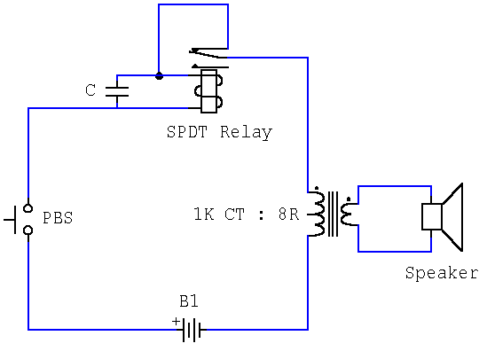

Fig 11.1- Buzzer Circuit

This novel buzzer circuit uses a relay in series with a small audio transformer and speaker. When the switch is pressed, the relay will operate via the transformer primary and closed relay contact. As soon as the relay operates the normally closed contact will open, removing power from the relay, the contacts close and the sequence repeats, all very quickly...so fast that the pulse of current causes fluctuations in the transformer primary, and hence secondary.

The speakers tone is thus proportional to relay operating frequency. The capacitor C can be used to "tune" the note. The nominal value is 0.001uF, increasing capacitance lowers the buzzers tone.

