CHAPTER 9
LIQUID CRYSTAL DISPLAY

9.1 INTRODUCTION

A liquid crystal display (commonly abbreviated LCD) is a thin, flat display device made up of any number of color or monochrome pixels arrayed in front of a light source or reflector. It is often utilized in battery-powered electronic devices because it uses very small amounts of electric power.

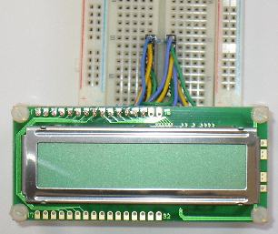

Fig 9.1- LCD Module

9.2 OVERVIEW
Each pixel of an LCD typically consists of a layer of molecules aligned between two transparent electrodes, and two polarizing filters, the axes of transmission of which are (in most of the cases) perpendicular to each other.
With no liquid crystal between the polarizing filters, light passing through the first filter would be blocked by the second (crossed) polarizer
The surfaces of the electrodes that are in contact with the liquid crystal material are treated so as to align the liquid crystal molecules in a particular direction. This treatment typically consists of a thin polymer layer that is unidirectionally rubbed using, for example, a cloth. The direction of the liquid crystal alignment is then defined by the direction of rubbing.
Before applying an electric field, the orientation of the liquid crystal molecules is determined by the alignment at the surfaces. In a twisted nematic device (still the most common liquid crystal device), the surface alignment directions at the two electrodes are perpendicular to each other, and so the molecules arrange themselves in a helical structure, or twist. Because the liquid crystal material is birefringent, light passing through one polarizing filter is rotated by the liquid crystal helix as it passes through the liquid crystal layer, allowing it to pass through the second polarized filter. Half of the incident light is absorbed by the first polarizing filter, but otherwise the entire assembly is transparent.

When a voltage is applied across the electrodes, a torque acts to align the liquid crystal molecules parallel to the electric field, distorting the helical structure (this is resisted by elastic forces since the molecules are constrained at the surfaces). This reduces the rotation of the polarization of the incident light, and the device appears gray. If the applied voltage is large enough, the liquid crystal molecules in the center of the layer are almost completely untwisted and the polarization of the incident light is not rotated as it passes through the liquid crystal layer. This light will then be mainly polarized perpendicular to the second filter, and thus be blocked and the pixel will appear black. By controlling the voltage applied across the liquid crystal layer in each pixel, light can be allowed to pass through in varying amounts thus constituting different levels of gray.
The optical effect of a twisted nematic device in the voltage-on state is far less dependent on variations in the device thickness than that in the voltage-off state. Because of this, these devices are usually operated between crossed polarizer’s such that they appear bright with no voltage (the eye is much more sensitive to variations in the dark state than the bright state). These devices can also be operated between parallel polarizer’s, in which case the bright and dark states are reversed. The voltage-off dark state in this configuration appears blotchy, however, because of small thickness variations across the device.
Both the liquid crystal material and the alignment layer material contain ionic compounds. If an electric field of one particular polarity is applied for a long period of time, this ionic material is attracted to the surfaces and degrades the device performance.
This is avoided either by applying an alternating current or by reversing the polarity of the electric field as the device is addressed (the response of the liquid crystal layer is identical, regardless of the polarity of the applied field).
When a large number of pixels is required in a display, it is not feasible to drive each directly since then each pixel would require independent electrodes. Instead, the display is multiplexed. In a multiplexed display, electrodes on one side of the display are grouped and wired together (typically in columns), and each group gets its own voltage source. On the other side, the electrodes are also grouped (typically in rows), with each group getting a voltage sink. The groups are designed so each pixel has a unique, unshared combination of source and sink. The electronics or the software driving the electronics then turns on sinks in sequence, and drives sources for the pixels of each sink.
9.3 SPECIFICATION
Important factors to consider when evaluating an LCD monitor
Resolution: The horizontal and vertical size expressed in pixels (e.g., 1024x768). Unlike CRT monitors, LCD monitors have a native-supported resolution for best display effect.
Dot pitch: The distance between the centers of two adjacent pixels. The smaller the dot pitch size, the less granularity is present, resulting in a sharper image. Dot pitch may be the same both vertically and horizontally, or different (less common).
Viewable size: The size of an LCD panel measured on the diagonal (more specifically known as active display area).
Response time: The minimum time necessary to change a pixel's color or brightness.
Matrix type: Active or Passive.
Viewing angle: (coll., more specifically known as viewing direction).
Color support: How many types of colors are supported (coll., more specifically known as color gamut).
Brightness: The amount of light emitted from the display (coll., more specifically known as luminance).
Contrast ratio: The ratio of the intensity of the brightest bright to the darkest dark.
Aspect ratio: The ratio of the width to the height (for example, 4:3, 16:9 or 16:10).

9.4 LCD MODULE INTERFACING WITH MICROCONTROLLER

The LCD Module can easily be used with an 8051 microcontroller such as the AT89C2051 included with the microcontroller beginner kit.
The LCD Module comes with a 16 pin connector. This can be plugged into the breadboard as shown below.
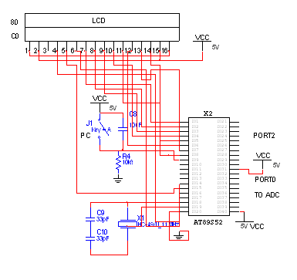

Fig 9.2 - LCD Interfacing Circuit Diagram

To connect the LCD Module to a standard 40 pin 8051, use the pin names listed below to find the correct pin number on the 8051 microcontroller. The example programs below do not need to be modified to work with a 40 pin 8051.
LCD  Connector | Function | 2051  Pin Number & Name |  |  |  | LCD  Connector | Function | 2051  Pin Number & Name
1 | Data Line 6 | 18, P1.6 |  |  |  | 16 | LCD RS | 7, P3.3
2 | Data Line 1 | 13, P1.1 |  |  |  | 15 | Data Line 5 | 17, P1.5
3 | Power - 5VDC |  |  |  |  | 14 | LCD Read/Write | 6, P3.2
4 | Not Connected |  |  |  |  | 13 | Data Line 0 | 12, P1.0
5 | Display Adjust |  |  |  |  | 12 | Data Line 4 | 16, P1.4
6 | Data Line 7 | 19, P1.7 |  |  |  | 11 | LCD Enable | 8, P3.4
7 | Data Line 2 | 14, P1.2 |  |  |  | 10 | Data Line 3 | 15, P1.3
8 | Ground |  |  |  |  | 9 | Not Connected
Table 9.1- LCD Connector Functions
Connect LCD Pin 3 to Vcc (5 Volts). Connect LCD Pin 8 to Ground. Connect a 510 ohm resistor between LCD Pin 5 and ground. Connect a 2.2k ohm resistor from LCD Pin 2 and Vcc. Connect a 2.2k ohm resistor from LCD Pin 13 to Vcc.

