DESIGN AND IMPLEMENTATION OF MECHANISM FOR STANDBY POWER REDUCTION IN HOME APPLIANCES

Abstract :
An embedded system is a general purpose computer system that is the combination of software and hardware designed to do a dedicated function with minimum manual interruption. It is mostly used for automation applications, since it reduces the size and cost of product as well processing time. Embedded system is now booming technology in various fields like industrial automation, home appliances, automobiles and aeronautics etc.

To save energy, we should consider not only power reduction in the electronic components itself but also efficient automatic control in network home environment. In this project we present s design approach and implementation result of control mechanism for standby power reduction.

Project Description:
This project “Design and Implementation of Mechanism for Standby Power Reduction in Home Appliances”, Provides the facility for the reduction of standby power. The standby power reduction system consist of a Host and network Agents. The Host is the brain of the system, various types of Agents which is attached to this system communicate between each other through the Host. Here the communication between the Host and Agent is made by means of ZigBee protocol.

This is the new standard designed for automation and control network. The standard is aiming to be a low cost, low power solution for systems consisting of devices in house, factories and offices. Expected Applications for the ZigBee are building automation, security system, remote control, remote meter reading and computer peripherals.

Block Diagram :

Diagram of Agent Component :

Antenna
Current
Transformer
Voltage

ZigBee
Module

Micro
Controller
Unit
Sensor
Sensor

Signal
Conditioning
Unit
Relay
Relay
Power Supply

Block Diagram of Host Component :

Antenna

ZigBee
Module

Micro
Controller
Unit
Display
Unit
Buzzer
Control Unit
(Key pad)
PIR
Sensor
Light
Sensor
Power Supply

Hardware Required :
- Microcontroller.
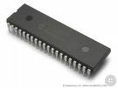
- Power Supply Unit.
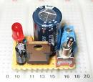
- PIR Sensor.
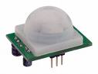
- LDR Sensor.
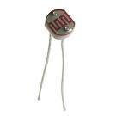
- Zigbee Module.
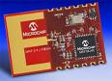
- Display Unit.
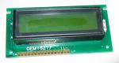
- Buzzer.
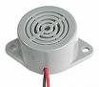

Software Required :
- Embedded C Language.
- KEIL Cross Compiler.

