power supply:
definition:
A power supply (sometimes known as a power supply unit or PSU) is a device or system that supplies electrical or other types of energy to an output load or group of loads. The term is most commonly applied to electrical energy supplies, less often to mechanical ones, and rarely to others.
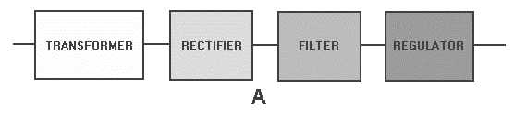
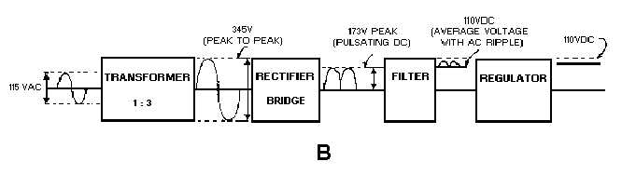

4-2 Figure 4-1A.—Block diagram of a basic power supply.
As illustrated in view B of figure 4-1, the first section is the TRANSFORMER.
The transformer steps up or steps down the input line voltage and isolates the power supply from the power line.
The RECTIFIER section converts the alternating current input signal to a pulsating direct current. However, as you proceed in this chapter you will learn that pulsating dc is not desirable. For this reason a FILTER section is used to convert pulsating dc to a purer, more desirable form of dc voltage.

Figure 4-1B.—Block diagram of a basic power supply. The final section, the REGULATOR, does just what the name implies. It maintains the output of the power supply at a constant level in spite of large changes in load current or input line voltages. Now that you know what each section does, let's trace an ac signal through the power supply. At this point you need to see how this signal is altered within each section of the power supply. Later on in the chapter you will see how these changes take place. In view B of figure 4-1, an input signal of 115 volts ac is applied to the primary of the transformer. The transformer is a step-up transformer with a turns ratio of 1:3. You can calculate the output for this transformer by multiplying the input voltage by the ratio of turns in the primary to the ratio of turns in the secondary; therefore, 115 volts ac ´ 3 = 345 volts ac (peak-to- peak) at the output. Because each diode in the rectifier section conducts for 180 degrees of the 360-degree input, the output of the rectifier will be one-half, or approximately 173 volts of pulsating dc. The filter section, a network of resistors, capacitors, or inductors, controls the rise and fall time of the varying signal; consequently, the signal remains at a more constant dc level. You will see the filter process more clearly in the discussion of the actual filter circuits. The output of the filter is a signal of 110 volts dc, with ac ripple riding on the dc. The reason for the lower voltage (average voltage) will be explained later in this chapter. The regulator maintains its output at a constant 110-volt dc level, which is used by the electronic equipment (more commonly called the load).

Simple 5V power supply for digital circuits

Summary of circuit features
- Brief description of operation: Gives out well regulated +5V output, output current capability of 100 mA
- Circuit protection: Built-in overheating protection shuts down output when regulator IC gets too hot
- Circuit complexity: Very simple and easy to build
- Circuit performance: Very stable +5V output voltage, reliable operation
- Availability of components: Easy to get, uses only very common basic components
- Design testing: Based on datasheet example circuit, I have used this circuit successfully as part of many electronics projects
- Applications: Part of electronics devices, small laboratory power supply
- Power supply voltage: Unregulated DC 8-18V power supply
- Power supply current: Needed output current + 5 mA
- Component costs: Few dollars for the electronics components + the input transformer cost

Circuit description:
This circuit is a small +5V power supply, which is useful when experimenting with digital electronics. Small inexpensive wall transformers with variable output voltage are available from any electronics shop and supermarket. Those transformers are easily available, but usually their voltage regulation is very poor, which makes then not very usable for digital circuit experimenter unless a better regulation can be achieved in some way. The following circuit is the answer to the problem.
This circuit can give +5V output at about 150 mA current, but it can be increased to 1 A when good cooling is added to 7805 regulator chip. The circuit has over overload and therminal protection.
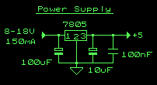
Circuit diagram of the power supply.
The capacitors must have enough high voltage rating to safely handle the input voltage feed to circuit. The circuit is very easy to build for example into a piece of Vero board.
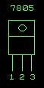
Pinout of the 7805 regulator IC.
- 1. Unregulated voltage in
- 2. Ground
- 3. Regulated voltage out

Component list:
7805 regulator IC
100 uF electrolytic capacitor, at least 25V voltage rating
10 uF electrolytic capacitor, at least 6V voltage rating
100 nF ceramic or polyester capacitor

Modification ideas

More output current
If you need more than 150 mA of output current, you can update the output current up to 1A doing the following modifications:
- Change the transformer from where you take the power to the circuit to a model which can give as much current as you need from output
- Put a heat sink to the 7805 regulator (so big that it does not overheat because of the extra losses in the regulator)

Other output voltages
If you need other voltages than +5V, you can modify the circuit by replacing the 7805 chips with another regulator with different output voltage from regulator 78xx chip family. The last numbers in the chip code tells the output voltage. Remember that the input voltage must be at least 3V greater than regulator output voltage to otherwise the regulator does not work well.

