INTELLIGENT TRAIN ENGINE

PROJECT WORK 2009-2010

Submitted in partial fulfillment of
requirements for the award of Diploma

In

ELECTRONICS AND COMMUNICATION ENGINEERING

Presented by

G. GEETHA P. SARATH KUMAR
L. SHARMILA KUMARI K. S. ASHOK
G. GAYATHRI V. YUVARAJ

GUIDED BY
Er. S. VANAMALA B.E., M.E

DEPARTMENT OF ELECTRONICS AND COMMUNICATION ENGINEERING
P.T.Lee.CHENGALVARAYAN NAICKER POLYTECHNIC COLLEGE
VEPERY, CHENNAI – 600 007.

P.T.Lee.CHENGALVARAYAN NAICKER
POLYTECHNIC COLLEGE

DEPARTMENT OF ELECTRONICS AND COMMUNICATION ENGINEERING

Project Work

Register No :

BONAFIDE CERTIFICATE

This is the bonafide certificate of the work done by the Thiru / Selvi _________________________ of VI semester Full Time Electronics and communication Engineering Department during the year 2009-2010.

HEAD OF THE DEPARTMENT PROJECT GUIDE

Submitted for the practical examination held on ________________________________

EXTERNAL EXAMINER INTERNAL EXAMINER

ACKNOWLEDGEMENT

We convey our sincere thanks to our principal Dr.L.RAMAJEYAM, M.E., (Structures) M.I.E., F.I.V., M.I.S.T.E., C Engg.(ind) for his kind permission and encouragement in carrying out this project work.

We express our thanks to the department incharge Er.T.UDHAYARANI M.E. for her constant encouragement and guidance rendered.

We express our thanks to our guide Er.S.VANAMALA B.E., M.E., for her guidance in completion of this project.

We express our thanks to all our staff members of the Electronics and Communication Engineering Department for their valuable help given.

P.T.Lee.C.N.POLYTECHNIC COLLEGE
VEPERY,
CHENNAI – 600 007.

CONTENTS

CONTENTS

- INTRODUCTION
- OBJECTIVES
- BLOCK DIAGRAM
- BLOCK DIAGRAM DESCRIPTION
- CIRCUIT DIAGRAM
- CIRCUIT DIAGRAM DESCRIPTION
- HARDWARE DETAILS
- SOFTWARE DETAILS
- ADVANTAGES
- APPLICATION
- BIBLIOGRAPHY
- CONCLUSION

INTRODUCTION

OBJECTIVES

BLOCK DIAGRAM

BLOCK DIAGRAM DESCRIPTION

CIRCUIT DIAGRAM

CIRCUIT DIAGRAM DESCRIPTION

HARDWARE DETAILS

SOFTWARE
DETAILS

ADVANTAGES

APPLICATION

BIBLIOGRAPHY

CONCLUSION

BIBLIOGRAPHY

BOOKS :

- ADVANCED MICROPROCESSOR AND MICROCONTROLLER

- B.P.SINGH

- MICROCONTROLLER AND EMBEDDED SYSTEM

- MOHAMMED ALI MAZIDI

MAGAZINE :

- ELECTRONICS FOR U

- PRACTICAL ELECTRONICS

WEBSITES :

www.datasheets4u.com

www.hitachi.com

www.atmel.com

www.wikipedia.com

www.altavista.com

INTRODUCTION:

Whenever any engine observer a red signal on its track it will start decreasing its speed gradually and stops automatically at some distance from the signal pole. After then when it gets green signal the driver can maintain start the train and go on. In the mean time when train has not stopped yet and a red signal becomes green then it crosses the signal pole with low speed and then driver can slowly increase the speed.
So now before the driver observes the red signal the engine itself observes it and automatically starts decreasing speed and then stops. The driver can feel relax in driving because he doesn’t have to take care about red signals. Even if driver forgets to take any action on red signal then also we can avoid accidents by the implementation of this idea.

GENERAL DESCRIPTION:

What we have to do is we have to attach a transmitter with signal pole which will start transmitting signals only when the red light is on. If there is green light no transmission. The engine has a receiver which catches these transmitted signals and takes desire actions.

Both the transmitter and receiver are of RF type with minimum range of 2KM, so that train can get enough time to decrease its speed and stop before the signal pole with minimum swapping distance of 100-200 mt.

Here in our project we have used IR Transmitter and receiver instead of RF for demo purpose. But same idea can be easily implemented with RF also with a little more cost.

DEMONSTRATION MODEL DISCRIPTION:

The train engine runs on 24 V DC motor so that we can easily vary its speed by varying applied voltage. The switching voltage is applied in step of 18V, 12V, 15V and 9V (min speed). The 230V AC is step down to 24 V AC by 12-0-12,2Amperes step down transformer.

As shown in figure this 24V AC line runs parallel with track at the top of the train. Movable tapping are taken from this line and fed to the internal circuit of engine. These tapping slides as the train run on the track and give continuous supply to circuit. The IR sensor is placed at the top of the engine, senses the signal transmitted by IR Transmitter attached to signal pole. Train track is straight and 20ft long. Signal pole is placed at the end of track and train starts from farther end.
The Project is divided into two parts:
The transmitter is housed in signal pole and it is activated only when red light is ON.
The receiver is housed in engine which senses the IR Signal and takes suitable action.

DEMONSTRATION MODEL:

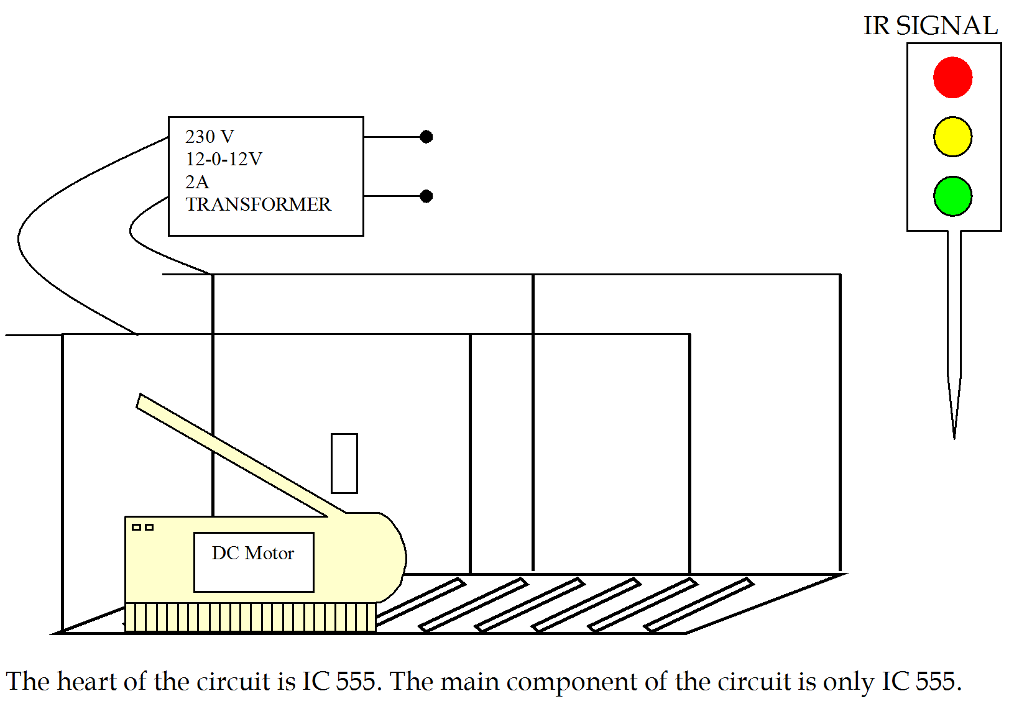

BLOCK DIAGRAM:

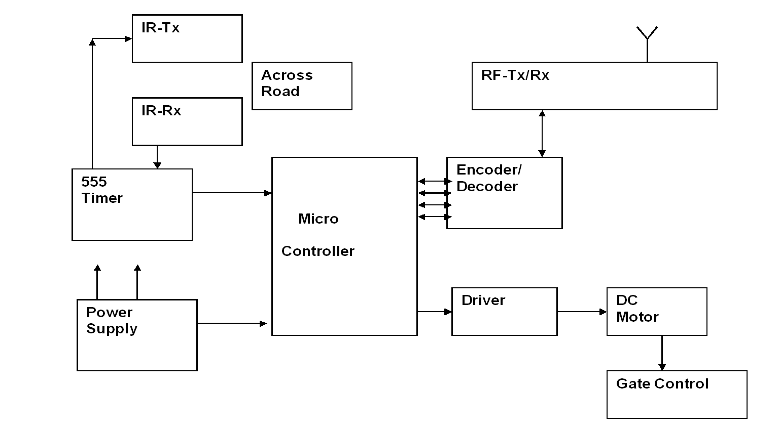

BLOCK DIAGRAM DISCRIPTION:

CONNECTION:

Both ICs are connected in astable mode. The frequency of U2 is 0.5Hz and U1 is 38 KHz. This is decided by RC components connected with it. The output of U2 is connected with reset. Pin U4 of U1. Thus the output of U2 controls the operation of U1 means it will switch ON of OFF. The output of U1. The output of U1 is fed to two IR LEDs through Darlington pair made up of Q1, Q2, and R5. The 9V DC battery is connected with circuit through SPDT switch SW1 as shown.

OPERATION:
As shown in figure when SW1 is in position as shown the transmitter is ON and also the red LED is also ON. When switch changes its position the red LED and transmitter is OFF and only green LED will on. When the circuit is energized U2 will start generating high pulse at every 1 sec. as this pulse is fed to reset pin of U1 it will generate 38 KHz square wave and give it to IR Leds. IR Leds will generate IR beam of 38 KHz for the the same time. Thus after every one second the IR Beam of 38Khz is generated for one second only. This cycle repeats till the red light is on.

ADVANTAGES:

- Prevent Accidents

- Safety to the Peoples

- Automatic Operation

- Fault analyze is easy

- Less expensive

HARDWARE REQUIREMENT:

- MC 89C51

- IR Sensor

- Buzzer

- Power Supply

- DC Motor

SOFTWARE USED:

- Keil software

- Embedded C

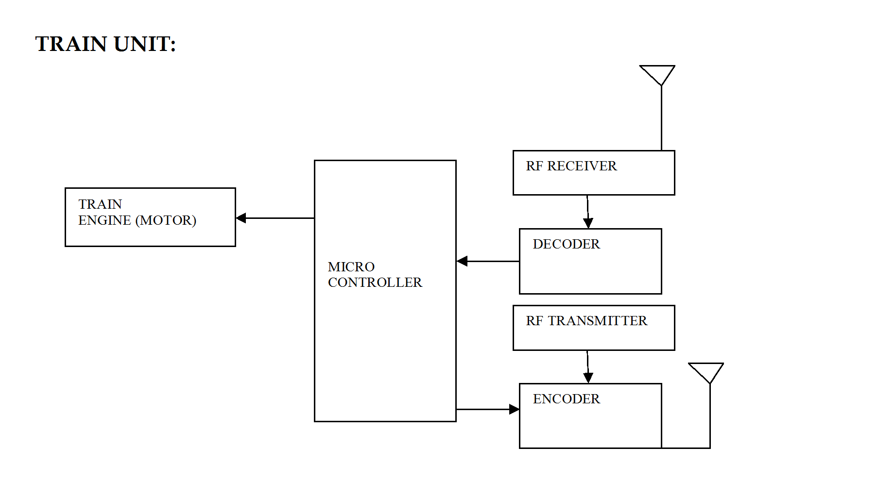

ENCODER AND DECODER
Encoder:
An encoder is a device used to change a signal (such as a bitstream) or data into a code. The code may serve any of a number of purposes such as compressing information for transmission or storage, encrypting or adding redundancies to the input code, or translating from one code to another. In digital electronics this would mean that a decoder is a multiple-input, multiple-output logic circuit(2^{n}-n).
Decoder:
A decoder is a device which does the reverse of an encoder, undoing the encoding so that the original information can be retrieved. The same method used to encode is usually just reversed in order to decode. In digital electronics this would mean that a decoder is a multiple-input, multiple-output logic circuit(n-2^{n}).

HT12E Features:
- Operating voltage
- 2.4V~5V for the HT12A
- 2.4V~12V for the HT12E
- Low power and high noise immunity CMOS technology
- Low standby current: 0.1_A (type.) at VDD=5V
- HT12A with a 38kHz carrier for infrared transmission medium
- Minimum transmission word
- Four words for the HT12E
- One word for the HT12A
- Built-in oscillator needs only 5% resistor
- Data code has positive polarity
- Minimal external components
- HT12A/E: 18-PIN DIP/20-PIN SOP package

The 2¹² encoders are a series of CMOS LSIs for remote control system applications. They are capable of encoding information which consists of N address bits and 12^{N} data bits. Each address/ data input can be set to one of the two logic states. The programmed addresses/data are transmitted together with the header bits via an RF or an infrared transmission medium upon receipt of a trigger signal. The capability to select a TE trigger on the HT12E or a DATA trigger on the HT12A further enhances the application flexibility of the 212 series of encoders. The HT12A additionally provides a 38 kHz carrier for infrared systems.

PIN description:
PIN A0-A7: Input pins for address A0~A7 setting
PIN AD8~AD11: Input pins for address/data AD8~AD11 setting
PIN D8~D11: Input pins for data D8~D11 setting and transmission enable, active low
PIN DOUT: Encoder data serial transmission output
PIN L/MB: Latch/Momentary transmission format selection PIN:
PIN : Transmission enable, active low
PIN OSC1: Oscillator input pin.
PIN OSC2: Oscillator output pin.
PIN X1: 455 kHz resonator oscillator input.
PIN X2: 455 kHz resonator oscillator output
PIN VSS: Negative power supply, grounds
PIN VDD: Positive power supply

Functional Description
Operation

The 2¹² series of encoders begin a 4-word transmission cycle upon receipt of a transmission enable (TE for the HT12E or D8~D11 for the HT12A, active low). This cycle will repeat the transmission enables returns high the encoder output completes its final cycle and then stops as shown below.itself as long as the transmission enable (TE or D8~D11) is held low. Once
Information word
If L/MB=1 the device is in the latch mode (for use with the latch type of data decoders). When the transmission enable is removed during a transmission, the DOUT pin outputs a complete word and then stops. On the other hand, if L/MB=0 the device is in the momentary mode (for use with the momentary type of data decoders). When the transmission enable is removed during a transmission, the DOUT outputs a complete word and then adds 7 words all with the ‘1’ data code.

An information word consists of 4 periods as illustrated below.
Address/data waveform
Each programmable address/data PIN can be externally set to one of the following two logic states as shown below.

PIN DESCRIPTION:

PIN A0~A11: Input pins for address A0~A11 setting
PIN D8~D11: Output data pins
PIN DIN: Serial data input pin
PIN VT: Valid transmission, active high
PIN OSC1: Oscillator input pin
PIN OSC2: Oscillator output pin
PIN VSS: Negative power supply (GND)
PIN VDD: Positive power supply

Functional Description
Operation

The 2¹² series of decoders provides various combinations of addresses and data pins in different packages so as to pair with the 2¹² series of encoders. The decoders receive data that are transmitted by an encoder and interpret the first N bits of code period as addresses and the last 12_N bits as data, where N is the address code number. A signal on the DIN pin activates the oscillator which in turn decodes the incoming address and data. The decoders will then check the received address three times continuously. If the received address codes all match the contents of the decoder’s local address, the 12_N bits of data are decoded to activate the output pins and the VT pin is set high to indicate a valid transmission. This will last unless the address code is incorrect or no signal is received. The output of the VT pin is high only when the transmission is valid. Otherwise it is always low.

Output type
Of the 2¹² series of decoders, the HT12F has no data output pin but its VT pin can be used as a momentary data output. The HT12D, on the other hand, provides 4 latch type data pins whose data remain unchanged until new data are received.

HARDWARE ARCHITECTURE

4.1 Power supply unit
A power supply (sometimes known as a power supply unit or PSU) is a device or system that supplies electrical or other types of energy to an output load or group of loads. The term is most commonly applied to electrical energy supplies, less often to mechanical ones, and rarely to others.

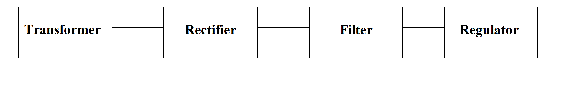
Transformer

Rectifier
Filter
Regulator
Fig4.1 Block diagram of power supply
110VDC
(AVERAGE VOLTAGE WITH AC ROPPLE)

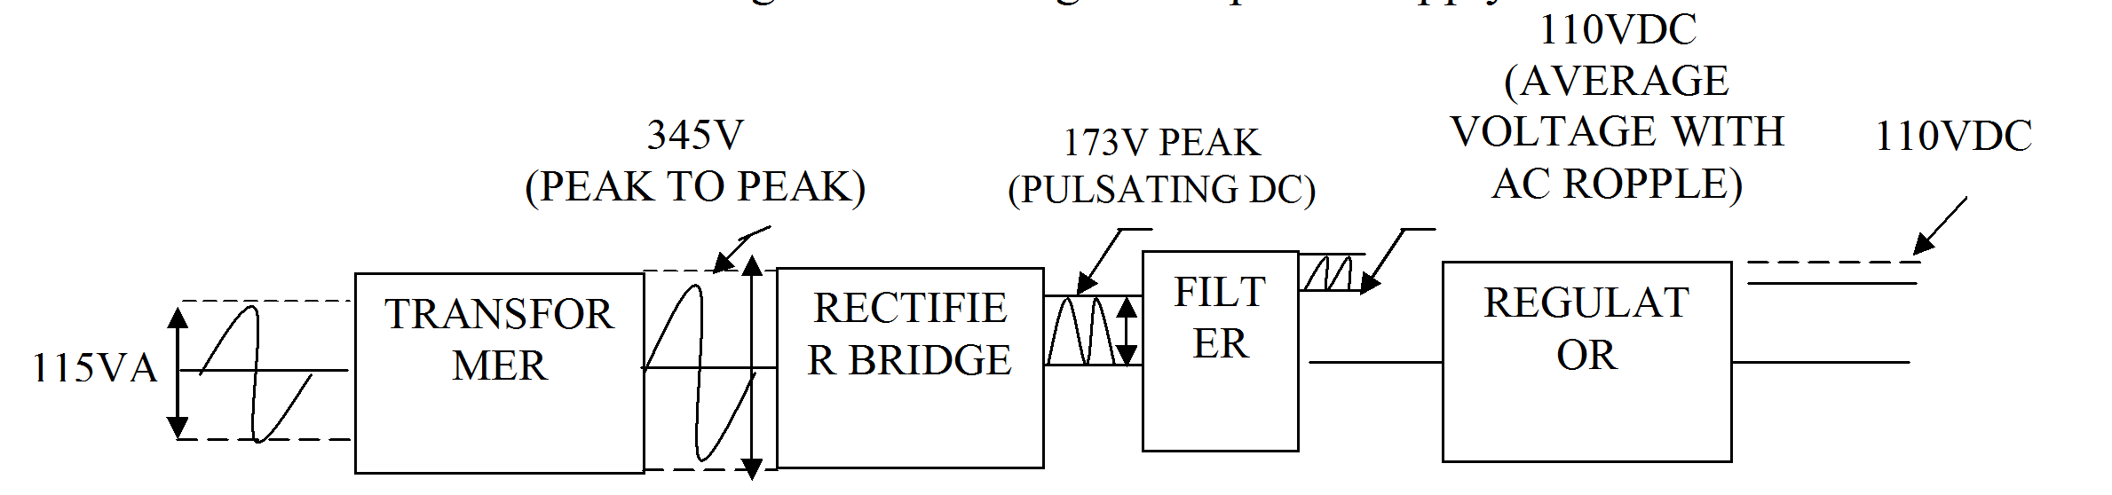
110VDC
345V
(PEAK TO PEAK)

Fig 4.2 processing of power supply
TRANSFORMER
RECTIFIER BRIDGE
FILTER
REGULATOR
115VAC

The transformer steps up or steps down the input line voltage and isolates the power supply from the power line. The RECTIFIER section converts the alternating current input signal to a pulsating direct current. However, as you proceed in this chapter you will learn that pulsating dc is not desirable. For this reason a FILTER section is used to convert pulsating dc to a purer, more desirable form of dc voltage.

The final section, the REGULATOR, does just what the name implies. It maintains the output of the power supply at a constant level in spite of large changes in load current or input line voltages. Now that you know what each section does, let's trace an ac signal through the power supply. At this point you need to see how this signal is altered within each section of the power supply. Later on in the chapter you will see how these changes take place. An input signal of 115 volts ac is applied to the primary of the transformer.

The transformer is a step-up transformer with a turns ratio of 1:3. You can calculate the output for this transformer by multiplying the input voltage by the ratio of turns in the primary to the ratio of turns in the secondary; therefore, 115 volts ac ´ 3 = 345 volts ac (peak-to- peak) at the output. Because each diode in the rectifier section conducts for 180 degrees of the 360-degree input, the output of the rectifier will be one-half, or approximately 173 volts of pulsating dc.

The filter section, a network of resistors, capacitors, or inductors, controls the rise and fall time of the varying signal; consequently, the signal remains at a more constant dc level. You will see the filter process more clearly in the discussion of the actual filter circuits. The output of the filter is a signal of 110 volts dc, with ac ripple riding on the dc. The reason for the lower voltage (average voltage) will be explained later in this chapter. The regulator maintains its output at a constant 110-volt dc level, which is used by the electronic equipment (more commonly called the load).

4.1.1 Simple 5V power supply for digital circuits
- Brief description of operation: Gives out well regulated +5V output, output current capability of 100 mA
- Circuit protection: Built-in overheating protection shuts down output when regulator IC gets too hot
- Circuit complexity: Very simple and easy to build
- Circuit performance: Very stable +5V output voltage, reliable operation
- Availability of components: Easy to get, uses only very common basic components
- Design testing: Based on datasheet example circuit, I have used this circuit successfully as part of many electronics projects
- Applications: Part of electronics devices, small laboratory power supply

- Power supply voltage: Unregulated DC 8-18V power supply
- Power supply current: Needed output current + 5 mA
- Component costs: Few dollars for the electronics components + the input transformer cost

RF transmitter and receiver:

Rf transmitter module:
1 2 3 4

RF transmitter

Functional block of Tx section where 1,2,3,4 are the pins
1 - Antenna
2 - Data input
3 - Ground
4 - VCC

In this transmitting section the 1st pin is the antenna pin where we can able to fix the antenna for transmitting the data in the Radio Frequency, the 2nd pin is the data input pin in which the output of the encoder is given; the 3rd pin is the ground and the 4th pin is the VCC which is given to operate the transmitter section.

RF receiver module:
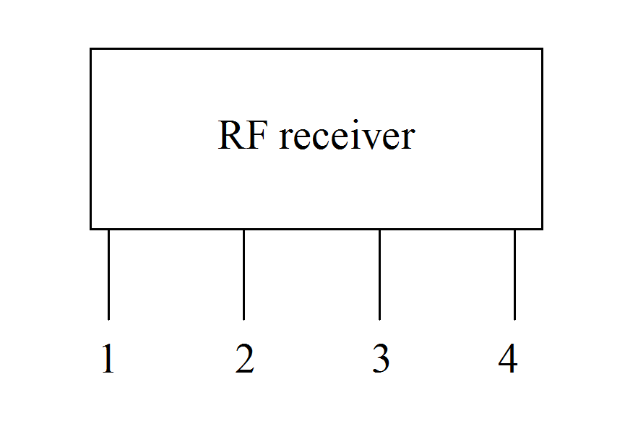
Functional block of Rx section where 1,2,3,4 are the pins
1 - Antenna
2 - Data input
3 - Ground
4 - VCC

In this receiving section the 1st pin is the antenna pin where we can able to fix the antenna to receive the data in the Radio Frequency, the 2nd pin is the data output pin to the decoder circuit, the 3rd pin is the ground and the 4th pin is the VCC which is given to operate the receiver section.

